Name:

- - - - - - - - - - - - - - - - - - - - - - - - - - - - - - - - - - - - - - - - - - - - - - - - - - __________________________________________________________

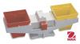
What's Heavier?

Fill in the circle under the item that is heavier.

or | 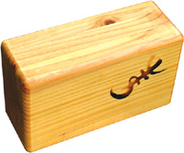  or
or | 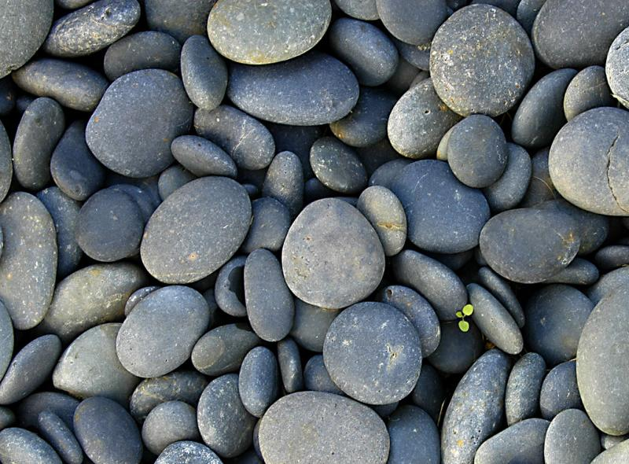  or
or | or
or | 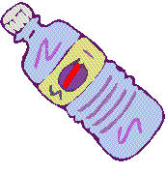  or

