Whales

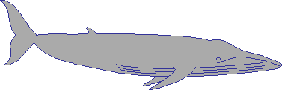  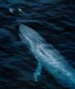 | 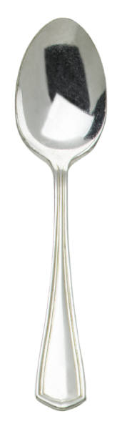  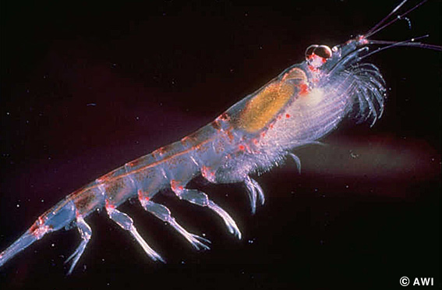  Blue Whale  Blue whales eat krill.  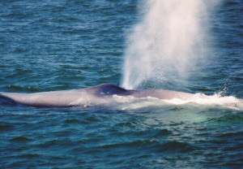  Blue whales have 2 blowholes.
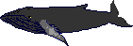  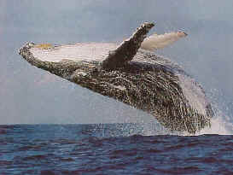 | Humpback Whale  Humpback whales eat krill.  Humpback whales like to jump out of the water.  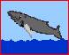
Dolphins

  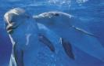 | Bottlenose Dolphin  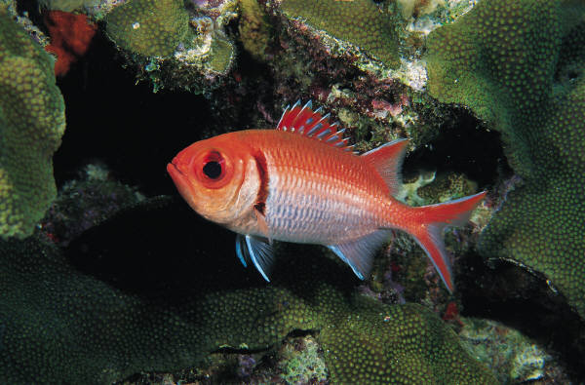  Dolphins eat fish and squid.  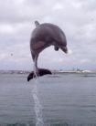  Bottlenose dolphins like to jump.
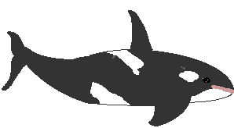  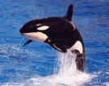 | Orca  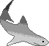  Orcas eat fish, squid, and s sharks.  Orcas are also called Killer Whales.
Sharks
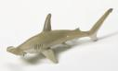  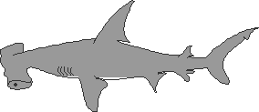 | Hammerhead Shark  Hammerhead sharks eat fish, squid, and sharks.
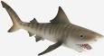  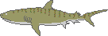 | 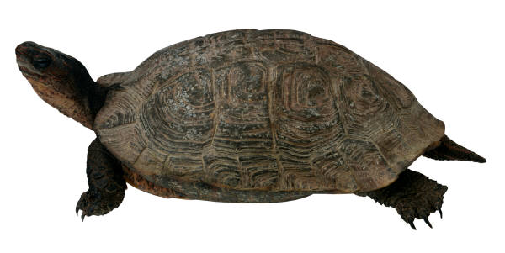  Tiger Shark  Tiger sharks eat fish, turtles, and sharks.
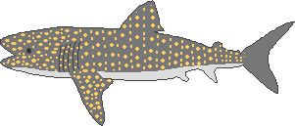  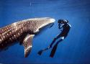 | Whale Shark  Whale sharks eat fish, krill, and s squid.

