Directions:
Print sheet on cardstock. Laminate. Cut puzzle apart on black lines so that you have eight pieces.

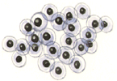
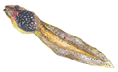
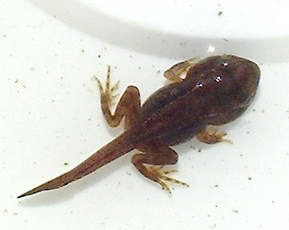
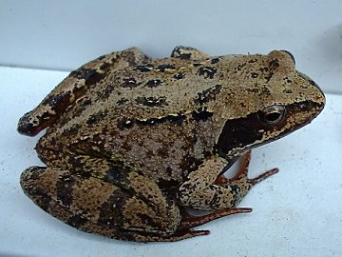
eggs
tadpole
froglet
frog

