spider  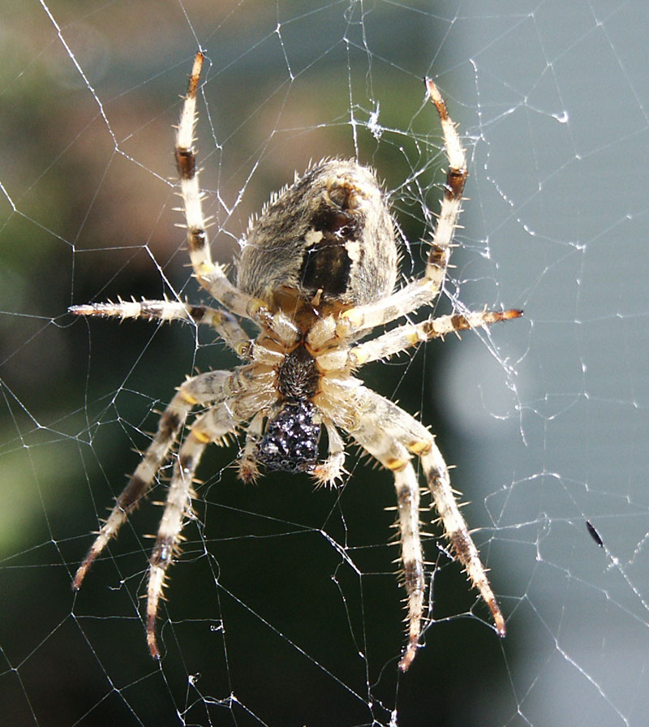  2 spinners  8 legs | ant  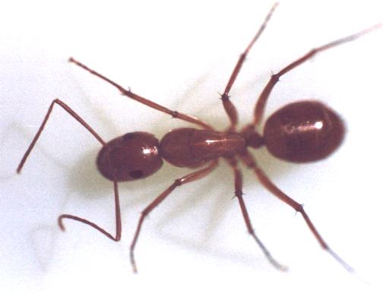  6 legs  2 feelers | fly  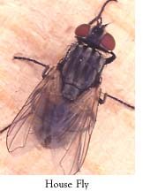  6 legs  2 wings  red eyes
dragonfly  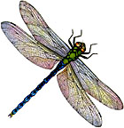  6 legs  4 wings  long body | bee  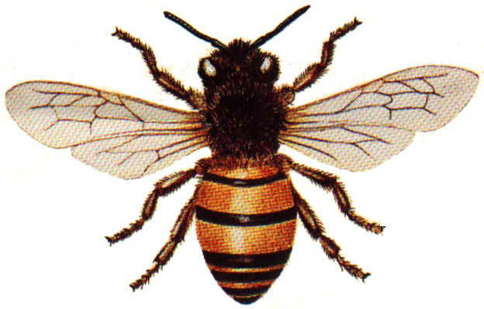  6 legs  2 wings  yellow and black | grasshopper  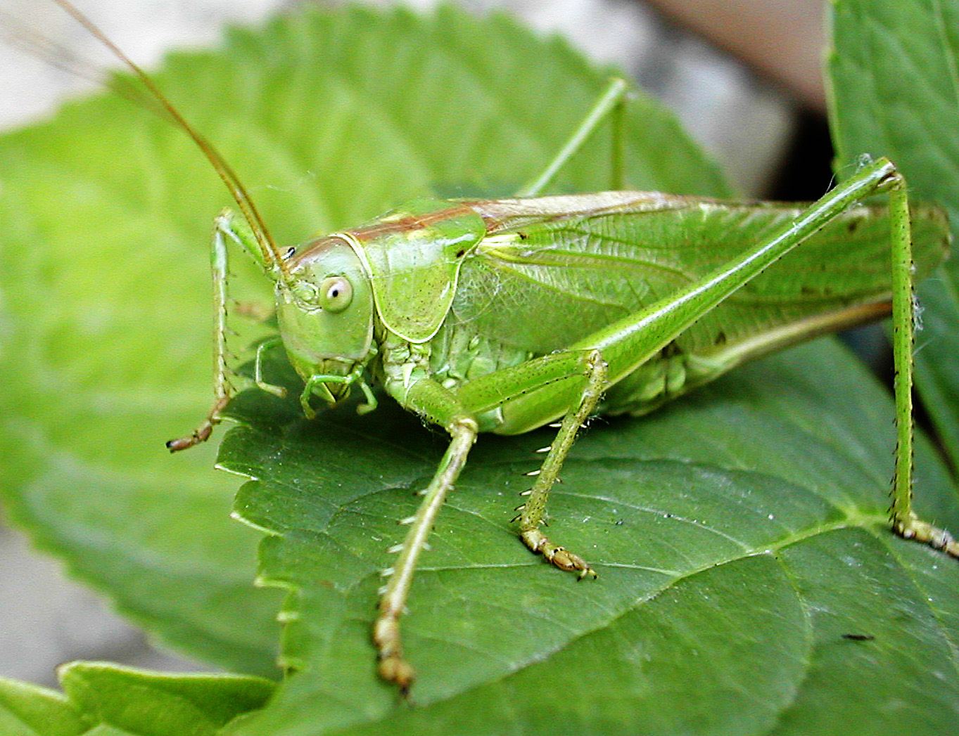  6 legs  green  2 antennas  2 wings folded

dragonfly | ant | grasshopper
bee | spider | fly

dragonfly | ant | grasshopper
bee | spider | fly

