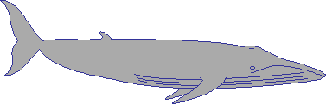    Whales | 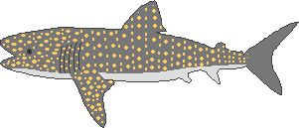  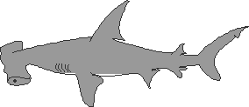  Sharks |   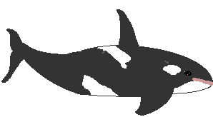  Dolphins
What Do We Eat?
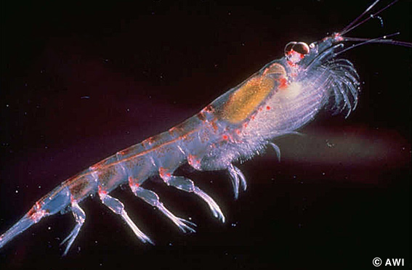
Who eats krill?
Who eats squid?
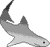
Who eats sharks?
Solve the clues?
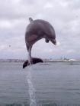
Who likes to jump?
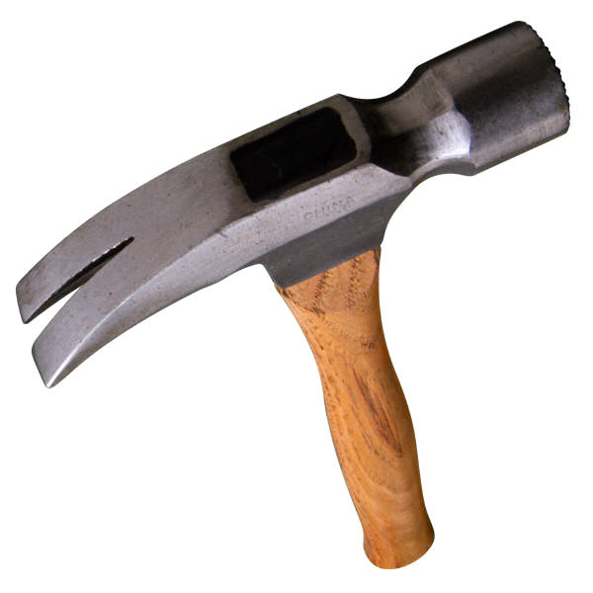
Who has a hammer shaped head?
Who has a dorsal fin on top?

