Name:

- - - - - - - - - - - - - - - - - - - - - - - - - - - - - - - - - - - - - - - - - - - - - - - - - -__________________________________________________________
Magnet Mystery
Choose a magnet. Test it on different objects in the classroom. Record your findings.

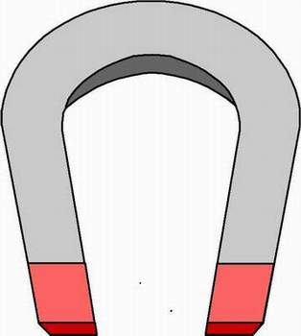  magnetic | not magnetic

