dog | cat | cut
box | dad | mom
nut | bus | gum

hug | cub | fox
jug | bat | hat
rat | bag | rag

pan | pot | fan
run | can |   man
van | map | nap

ham | jam | net
wet | vet | jet
hen | ten | pen

mad | sad | bed
red | leg | pig
wig | win | log

zip | dot | hot
mud | mop | top
hop | cup | sun

gun | hum | tug
pup | dig | 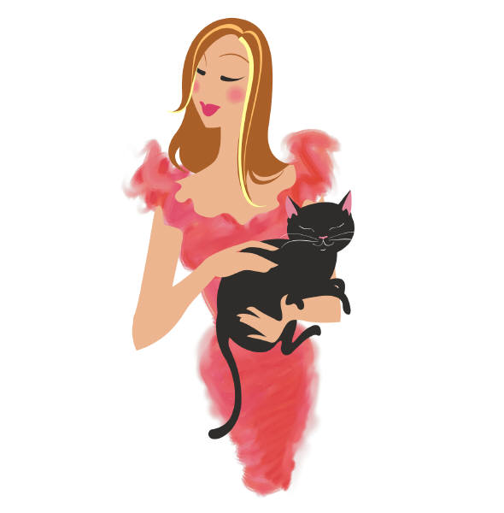  pet
fog | bit | bad

sip | lap | cob
hog | job | cop
hut | tap | bud

hit | bad | mug
gas | bug | web
rug | sit | tag

kid | rod | bun
beg | pin | big
pit | fin | lid

