Name:
- - - - - - - - - - - - - - - - - - - - - - - - - - - - - - - - - - - - - - - - - - - - - - - - - - - ____________________________________________________________

Read the words. Cut and glue the puzzle pieces.

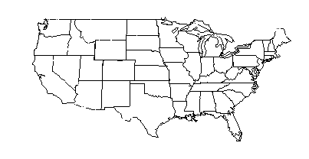

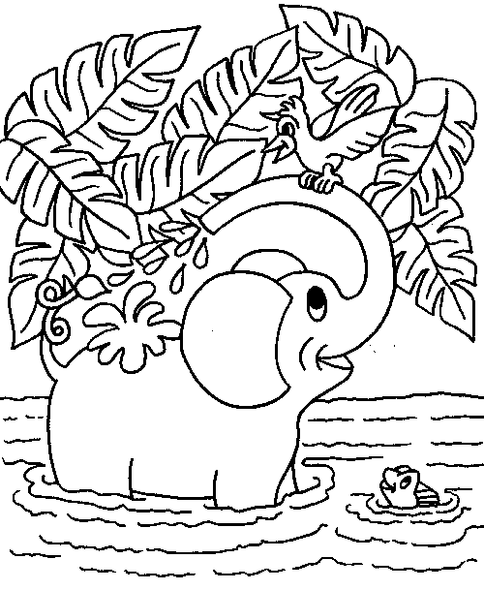  cat | jet | mop | bug
pin | bag | pan | map
cut | box | cup | hen

