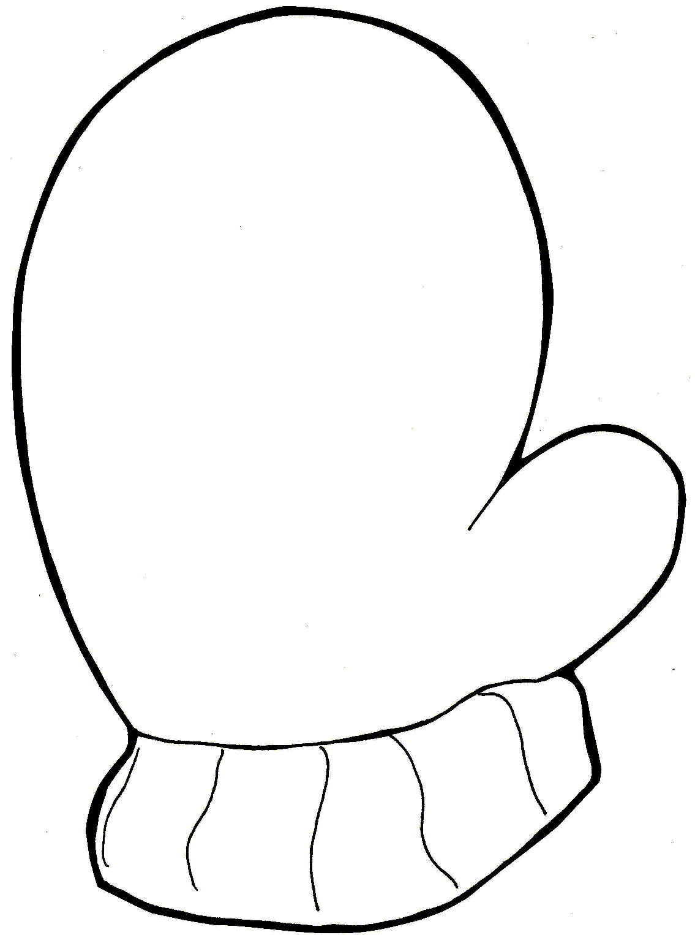
orange
red
red
blue
yellow
green
purple
orange
purple
blue
yellow
green
orange
red
red
blue
yellow
green
purple
orange
purple
blue
yellow
green

