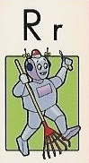
Name:

Glue
Write a sentence for each word.

