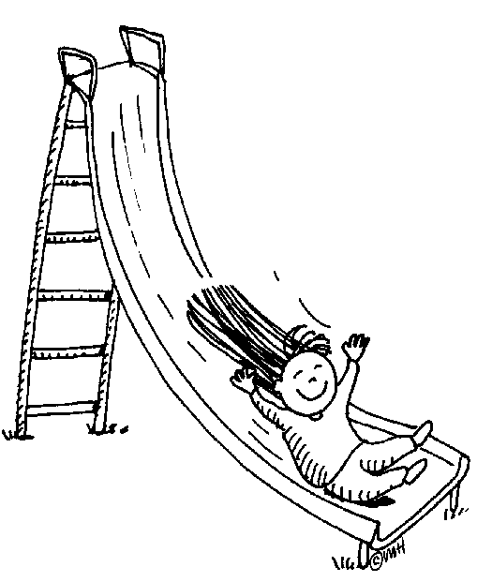  Safe Behavior  Keep hands, feet, and objects to self.  Stay in your assigned area.  Use equipment appropriately.  Run only where permitted. | 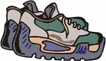  Well Prepared  Have appropriate attire and equipment.
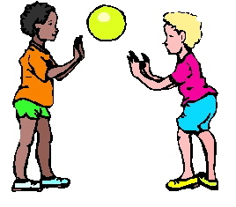  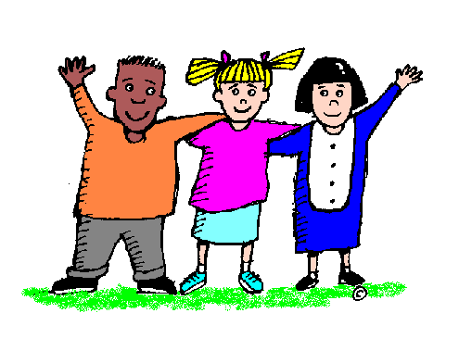  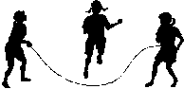  Incredibly Respectful  Take turns and play cooperatively.  Share equipment.  Include others.  Use kind and polite words. | Make Responsible Choices  Report problems to the teacher.  Clean up equipment.  Accept consequences without arguing or complaining.  Follow directions the first time.

