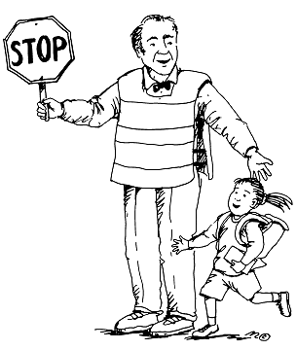  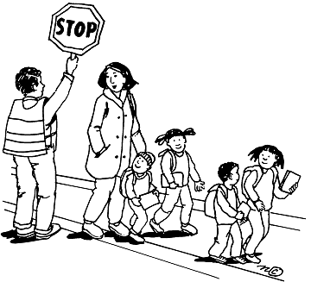  Safe Behavior  Keep hands, feet, and objects to self.  Use visible and supervised walkways.  Listen to crossing guards and staff.  Report unsafe items to school staff. | 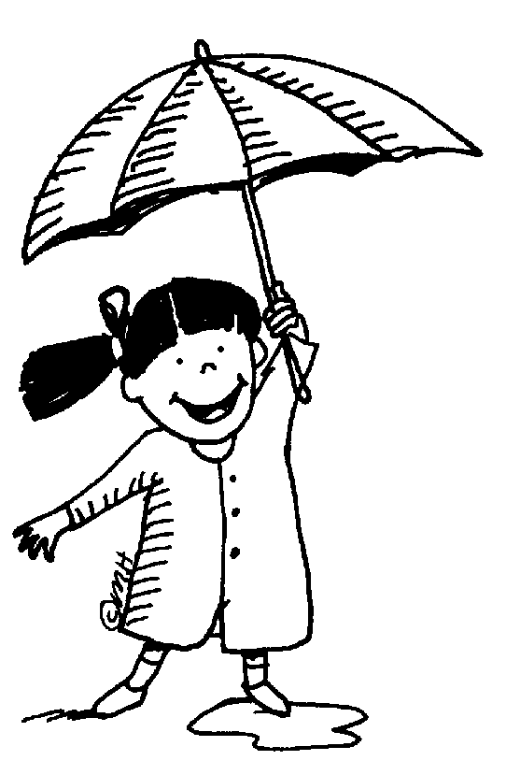  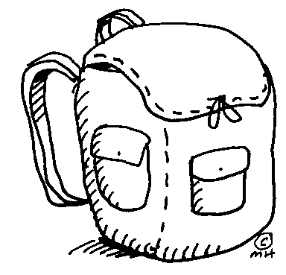  Well Prepared  Wear appropriate attire.  Bring appropriate materials to school.
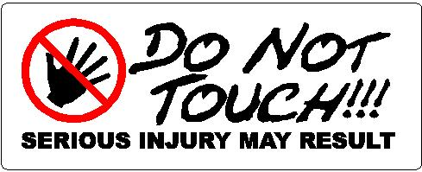  Incredibly Respectful  Use kind and polite words.  Respect property of others. | 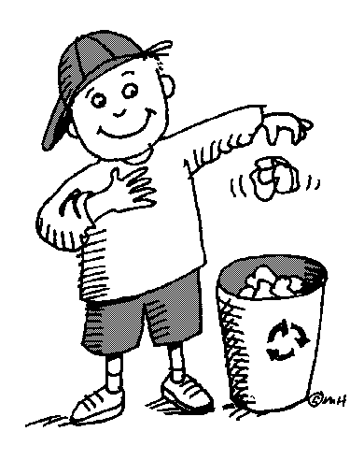  Make Responsible Choices  Report problems to an adult  Put trash in trash cans.  Avoid touching others.

