Safe Behavior  Keep hands, feet, and objects to self.  Walk slowly.  Keep your distance from others. | 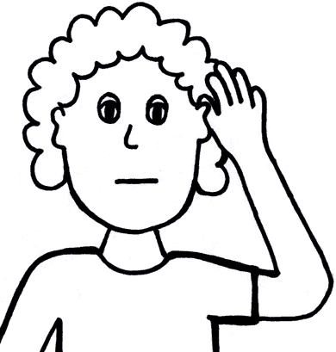  Well Prepared  Have a hall pass.  Face forward.  Listen to the teacher.  Watch the person in front of you.
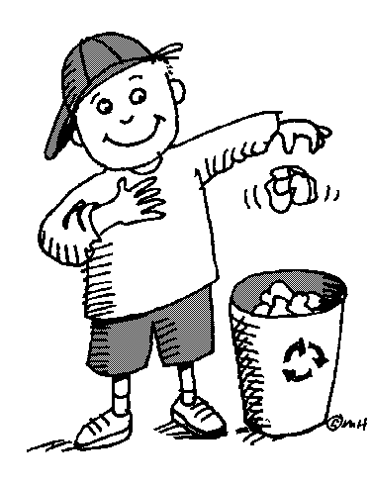  Incredibly Respectful  Walk silently.  Walk on the silver line.  Keep hallways neat and clean. | 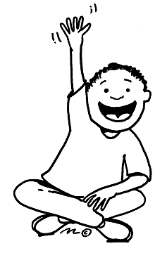  Make Responsible Choices  Raise your hand if you need assistance.  Avoid touching others.  Watch, listen, and follow teacher directions.

