 | Morning  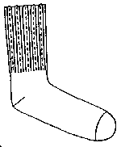  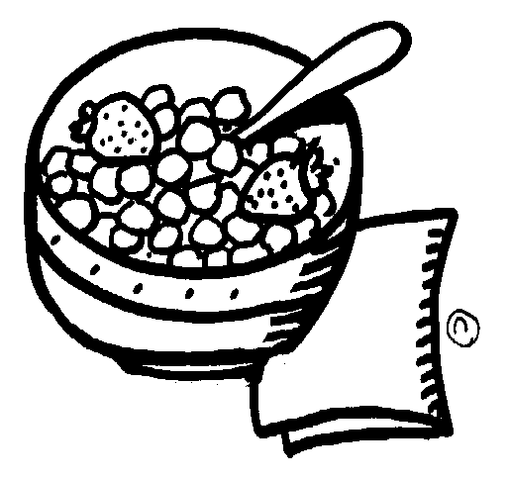 | 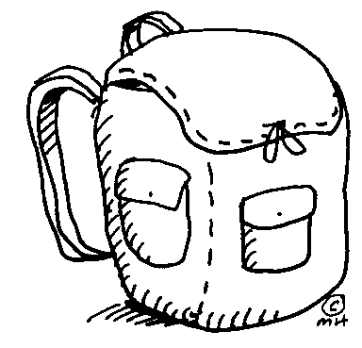  Homework | Dinner   | 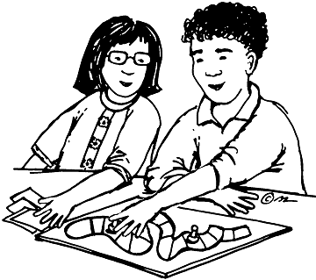  Playtime | Bath/PJ  Brush Teeth  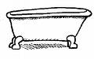  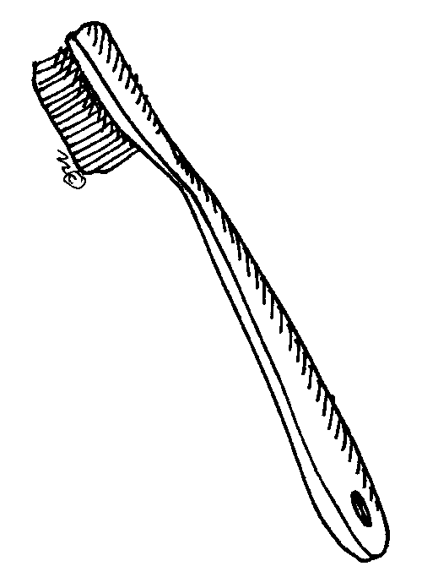 | Bedtime  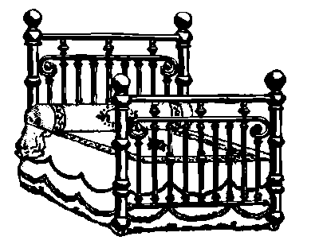 | Bonuses  
I followed directions  1st |  |  |  |  |  |  | 7:00 | 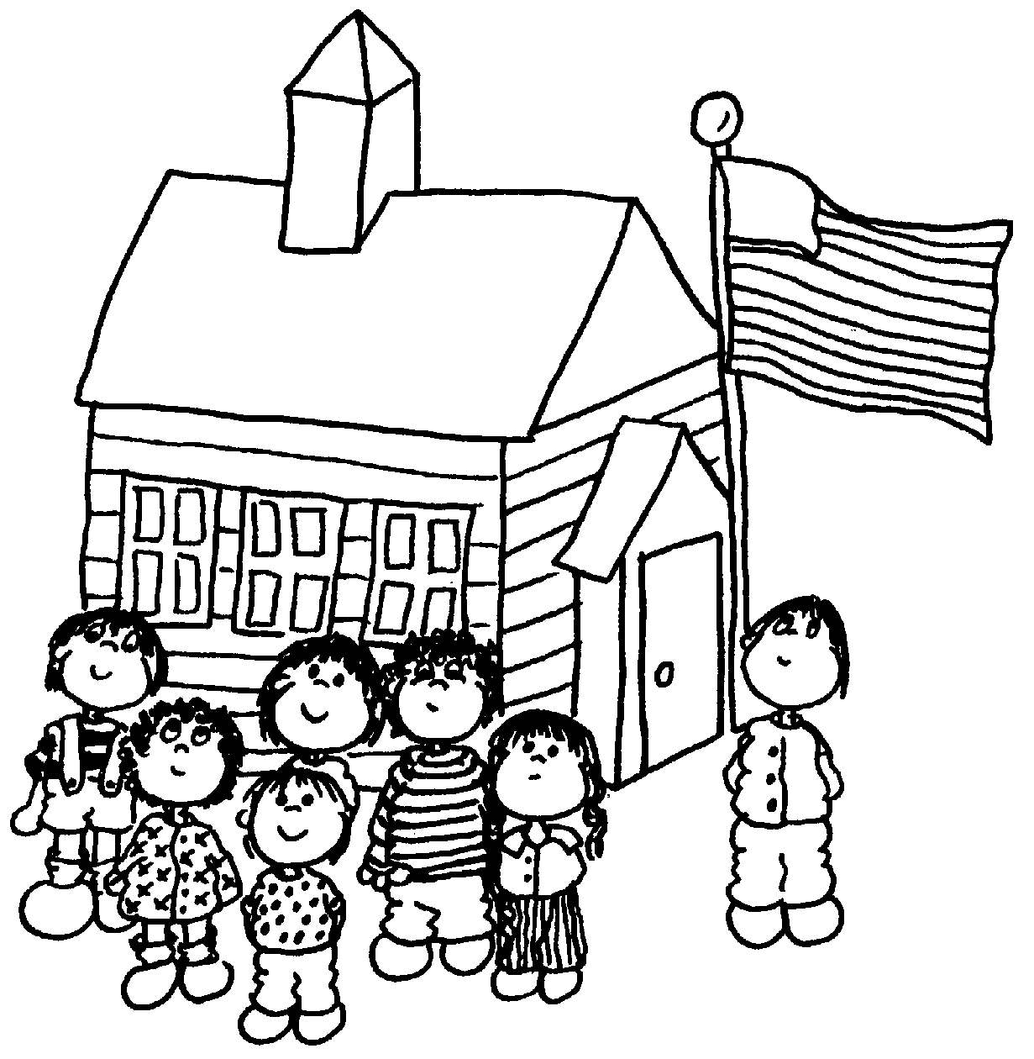
I was calm.
I did not argue.
I accepted my consequences.
I said nice things. |  |  |  |  |  |  | 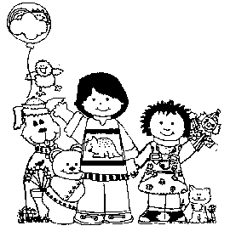

 | Morning |  | Homework |  | Dinner |  | Playtime |  |  | Bath/PJ  Brush Teeth |  | Bedtime |  | Bonuses
I followed directions  1st |  |  |  |  |  |  |  |  |  |  |  |  |  | 7:00
I was calm.
I did not argue.
I accepted my consequences.
I said nice things.
 | Morning |  |  | Lunch |  |  |  | Dinner | Playtime |  | Bath/PJ  Brush Teeth |  | Bedtime |  | Bonuses
I followed directions  1st |  |  |  |  |  |  |  |  |  |  |  |  |  |  | 7:00
I was calm.
I did not argue.
I accepted my consequences.
I said nice things.

 | Morning |  | Lunch |  | Dinner | Playtime | Bath/PJ  Brush Teeth | Bedtime | Bonuses
I followed directions  1st |  |  |  |  |  |  |  |  | 7:00
I was calm.
I did not argue.
I accepted my consequences.
I said nice things.

