Safe Behavior  Keep hands, feet, and objects to self.  Stay in your assigned area.  Use materials appropriately. | 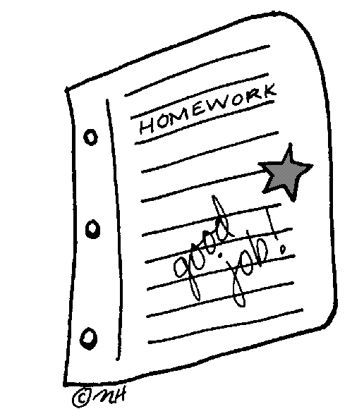  Well Prepared  Bring homework and materials needed to class.  Follow classroom routines.
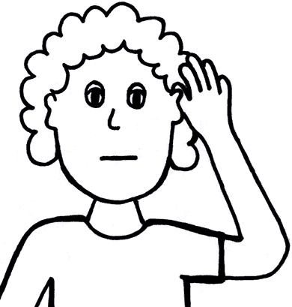  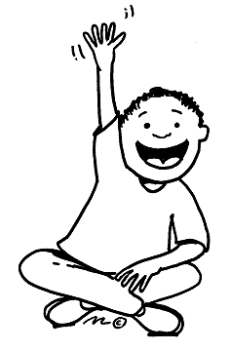  Incredibly Respectful  Raise your hand and wait to be called on.  Use polite and kind words.  Ask permission to use materials.  Listen politely when others are speaking.  Follow directions the first time. | Make Responsible Choices  Tell the teacher if you have a problem you can’t solve.  Complete your work.  Accept consequences without arguing or complaining.

