Safe Behavior  Keep hands, feet, and objects to self.  Walk carefully. | Well Prepared  Be ready to take your turn and return to class.  Have a pass at all times.  Only take necessary materials into the bathroom.
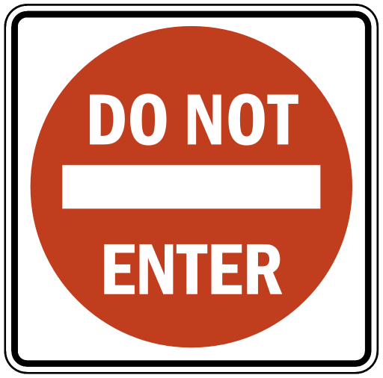  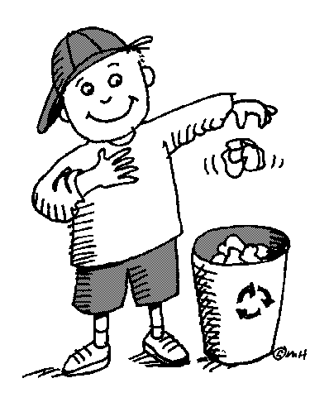  Incredibly Respectful  Use a quiet voice.  Respect the privacy of others.  Keep the bathroom clean.  Use facilities appropriately. | 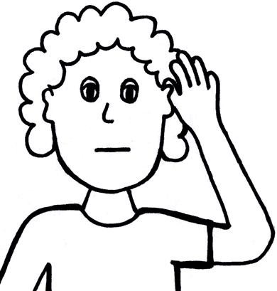  Make Responsible Choices  Report any problems to the teacher immediately.  Watch, listen, and follow teacher directions.

