
wet
wet

pet
pet

bed
bed

ten
ten



peg
peg

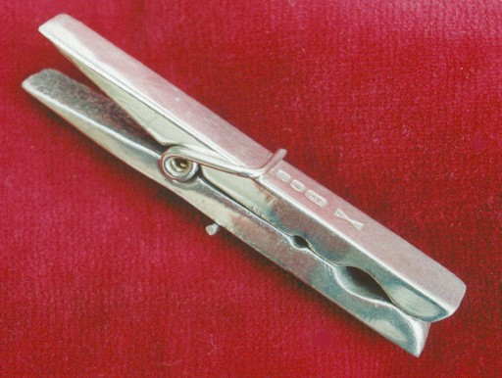

web
web

hen
hen

men
men



den

den

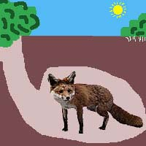

net
net

beg
beg



red
red

leg
leg

keg
keg

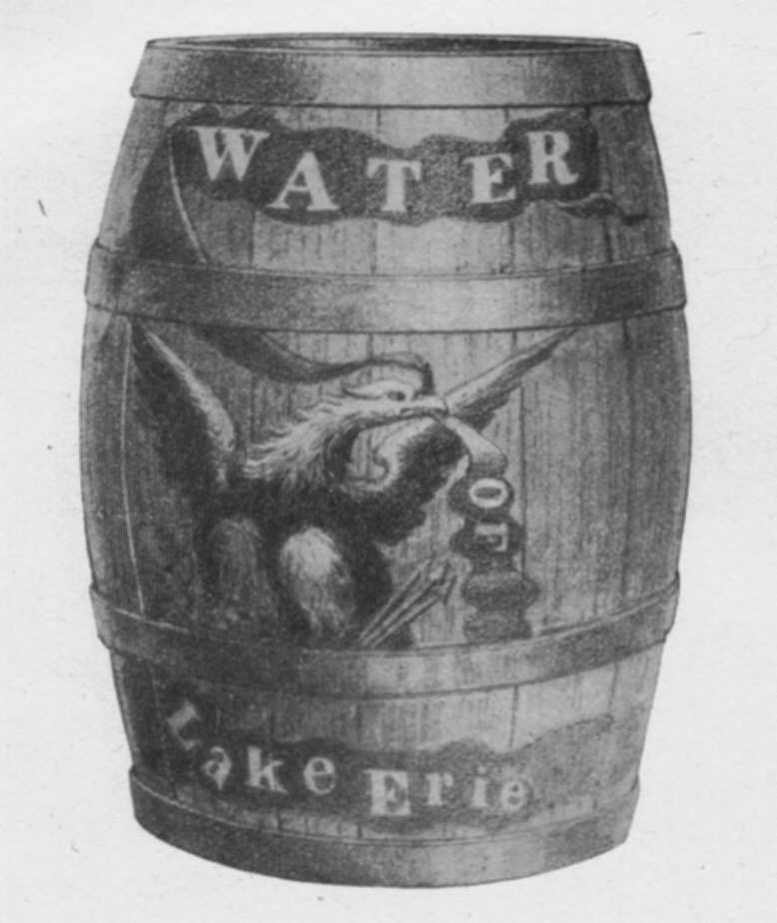

fed
fed

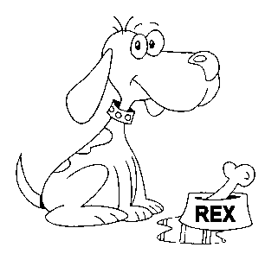

pen
pen

hem
hem

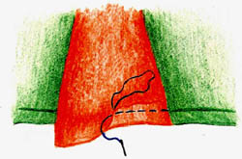

wed
wed

How to Play

- Two or three players sit facing each other.
- A dealer shuffles the cards well.
- Deal 5 cards face down to each player and themselves then places the remaining cards face down in the centre of the group.
- Players pick up their cards being careful that the others do not see the pictures or words on their cards.
- If players have matching cards they place them face down in front of them.
- The dealer then asks any other player if they have a card that matches on in their hand eg ‘Eric, do you have slop?’
- If the answer is yes then the card must be handed over so the questioner can make a pair. The questioner then places the pair down and asks another player for a different card.
- If the player doesn’t have the requested card they must say either ‘Go Fish’ and the questioner must pick up a card from the pile in the centre of the group.
- The game continues until there are no cards left.
- The winner is the person with the most pairs.

Go Fish

CVC
e
Words

This card is the pack’s cover Instruction cards are useful for parents if
you want to use the game for homework.

