Copycat

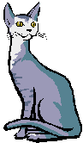
Been there, done that!

Stuck in your brain
Turtle talk

stop
stop
stop
stop

Phone a friend

