Name: ____________________________ Look Closer

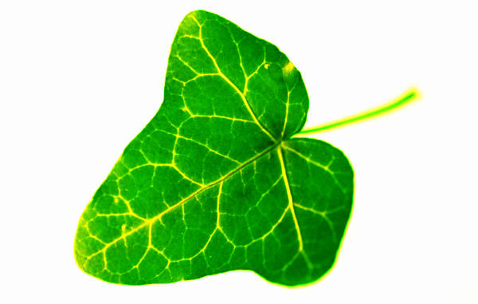
log
leaf
ladybug
_____ _____ _____ | _____ ____ ____ ____

____ ____ ____ ____ ____ ____ ____

