_ _ _ _ _ _ _ _ _ _ _ _ _ _ _ _ _ _ _ _ _ _ _ _ _ _ _ _ _ _ _ _ _ _ _ _ _ _ _ _ _ _ _ _ _ _ _ _ _ _ _ _ _ _ _ _ _ _ _ _ _ _ _ _ _ _ _ _ _ _ _ _ _ _ _ _ _ _ _ _

Eyes are Everywhere
Tell which animal sees this way.

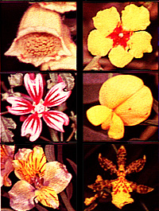  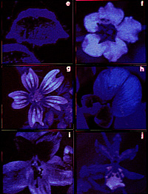  Who sees like this?  __________________________________________  _ _ _ _ _ _ _ _ _ _ _ _ _ _ _ _ _ _ _ _ _ _ _ _ _ _ _ _  __________________________________________ | 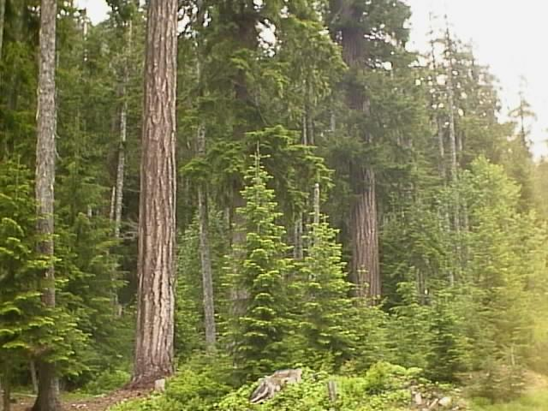  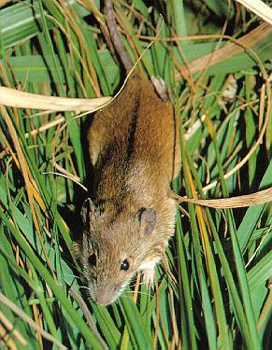  Who sees like this?  __________________________________________  _ _ _ _ _ _ _ _ _ _ _ _ _ _ _ _ _ _ _ _ _ _ _ _ _ _ _ _  __________________________________________
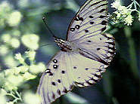  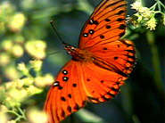  Who sees like this?  __________________________________________  _ _ _ _ _ _ _ _ _ _ _ _ _ _ _ _ _ _ _ _ _ _ _ _ _ _ _ _  __________________________________________ | 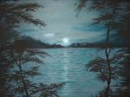  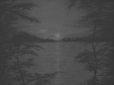  Who sees like this?  __________________________________________  _ _ _ _ _ _ _ _ _ _ _ _ _ _ _ _ _ _ _ _ _ _ _ _ _ _ _ _  __________________________________________

_ _ _ _ _ _ _ _ _ _ _ _ _ _ _ _ _ _ _ _ _ _ _ _ _ _ _ _ _ _ _ _ _ _ _ _ _ _ _ _ _ _ _ _ _ _ _ _ _ _ _ _ _ _ _ _ _ _ _ _ _ _ _ _ _ _ _ _ _ _ _ _ _ _ _ _ _ _ _ _

Eyes are Everywhere
Explain what is special about each animal’s vision.




                                                                 



