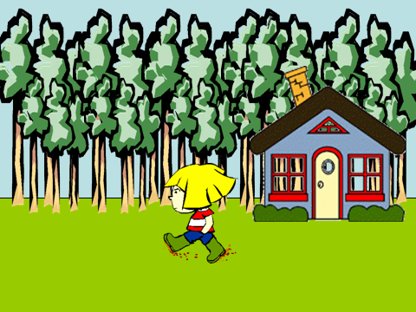

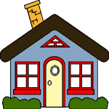
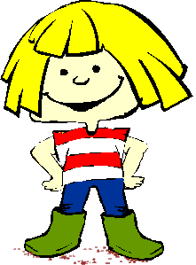 went .
home

12
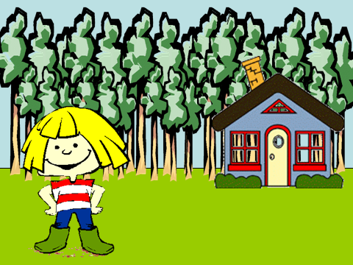

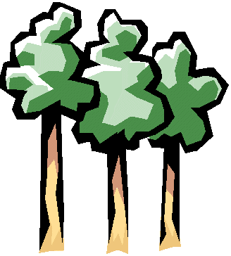
went for a  in the .
Goldilocks
walk
woods

house
She said, “I see a .”

1

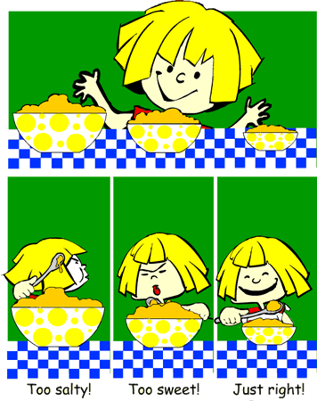

went in the .
house
Goldilocks
bowls
She said, “I see three .”

2

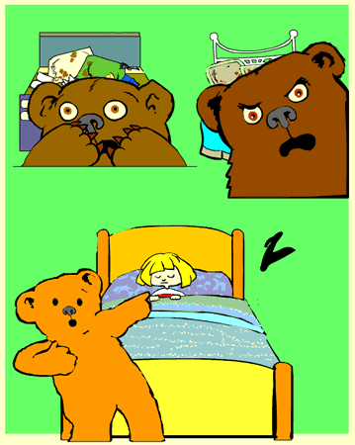

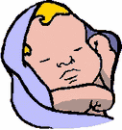
sleeping
bed

Someone is in my ! .
11

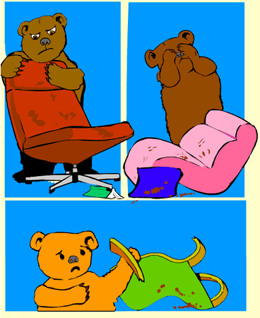

chair

broke
Someone my .

10

“This one is too .”
hot

cold
“This one is too .”

“This one is good !”

3

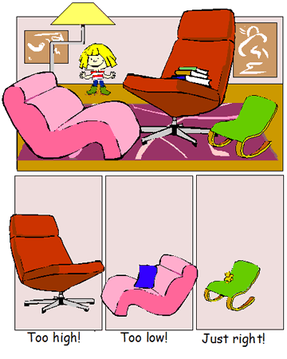

said, “I see three .”
chairs
Goldilocks

4

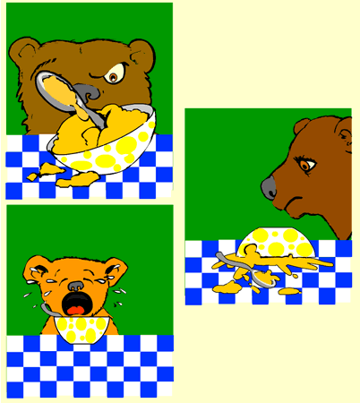

porridge

Someone ate my .

9

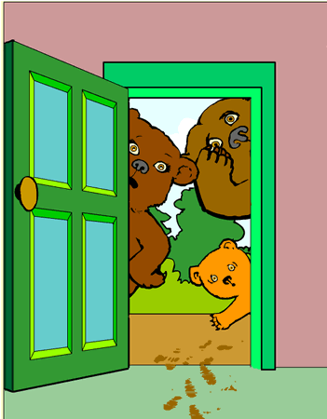

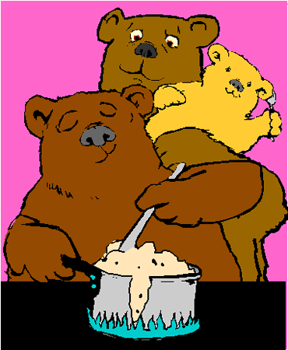
home
bears
The came .

8

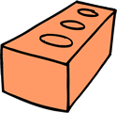
“This one is too .”
hard

soft
“This one is too .”

“This one is good !”

5

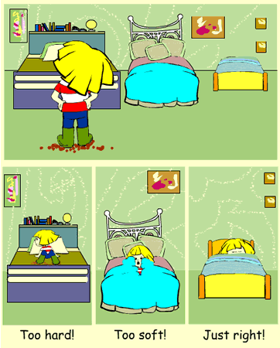

said, “I see three .”
beds
Goldilocks

6

“This one is too .”
high

“This one is too .”
low

“This one is good !”

went to .
sleep
Goldilocks
7

Goldilocks and the Three Bears
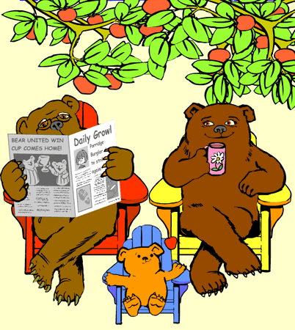

by: Ms. Nyman

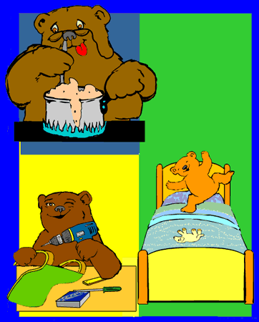

bears
porridge
The made some .
chairs
bears
The fixed the .

bears
beds
13
The made the .

