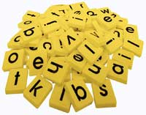

Find the matching lowercase letters.
A | a

A
E
B
F

C
G

D

