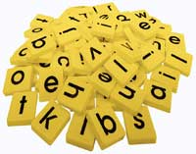

Find the matching letters.
a | a

a
b
c
d

e
f

g

