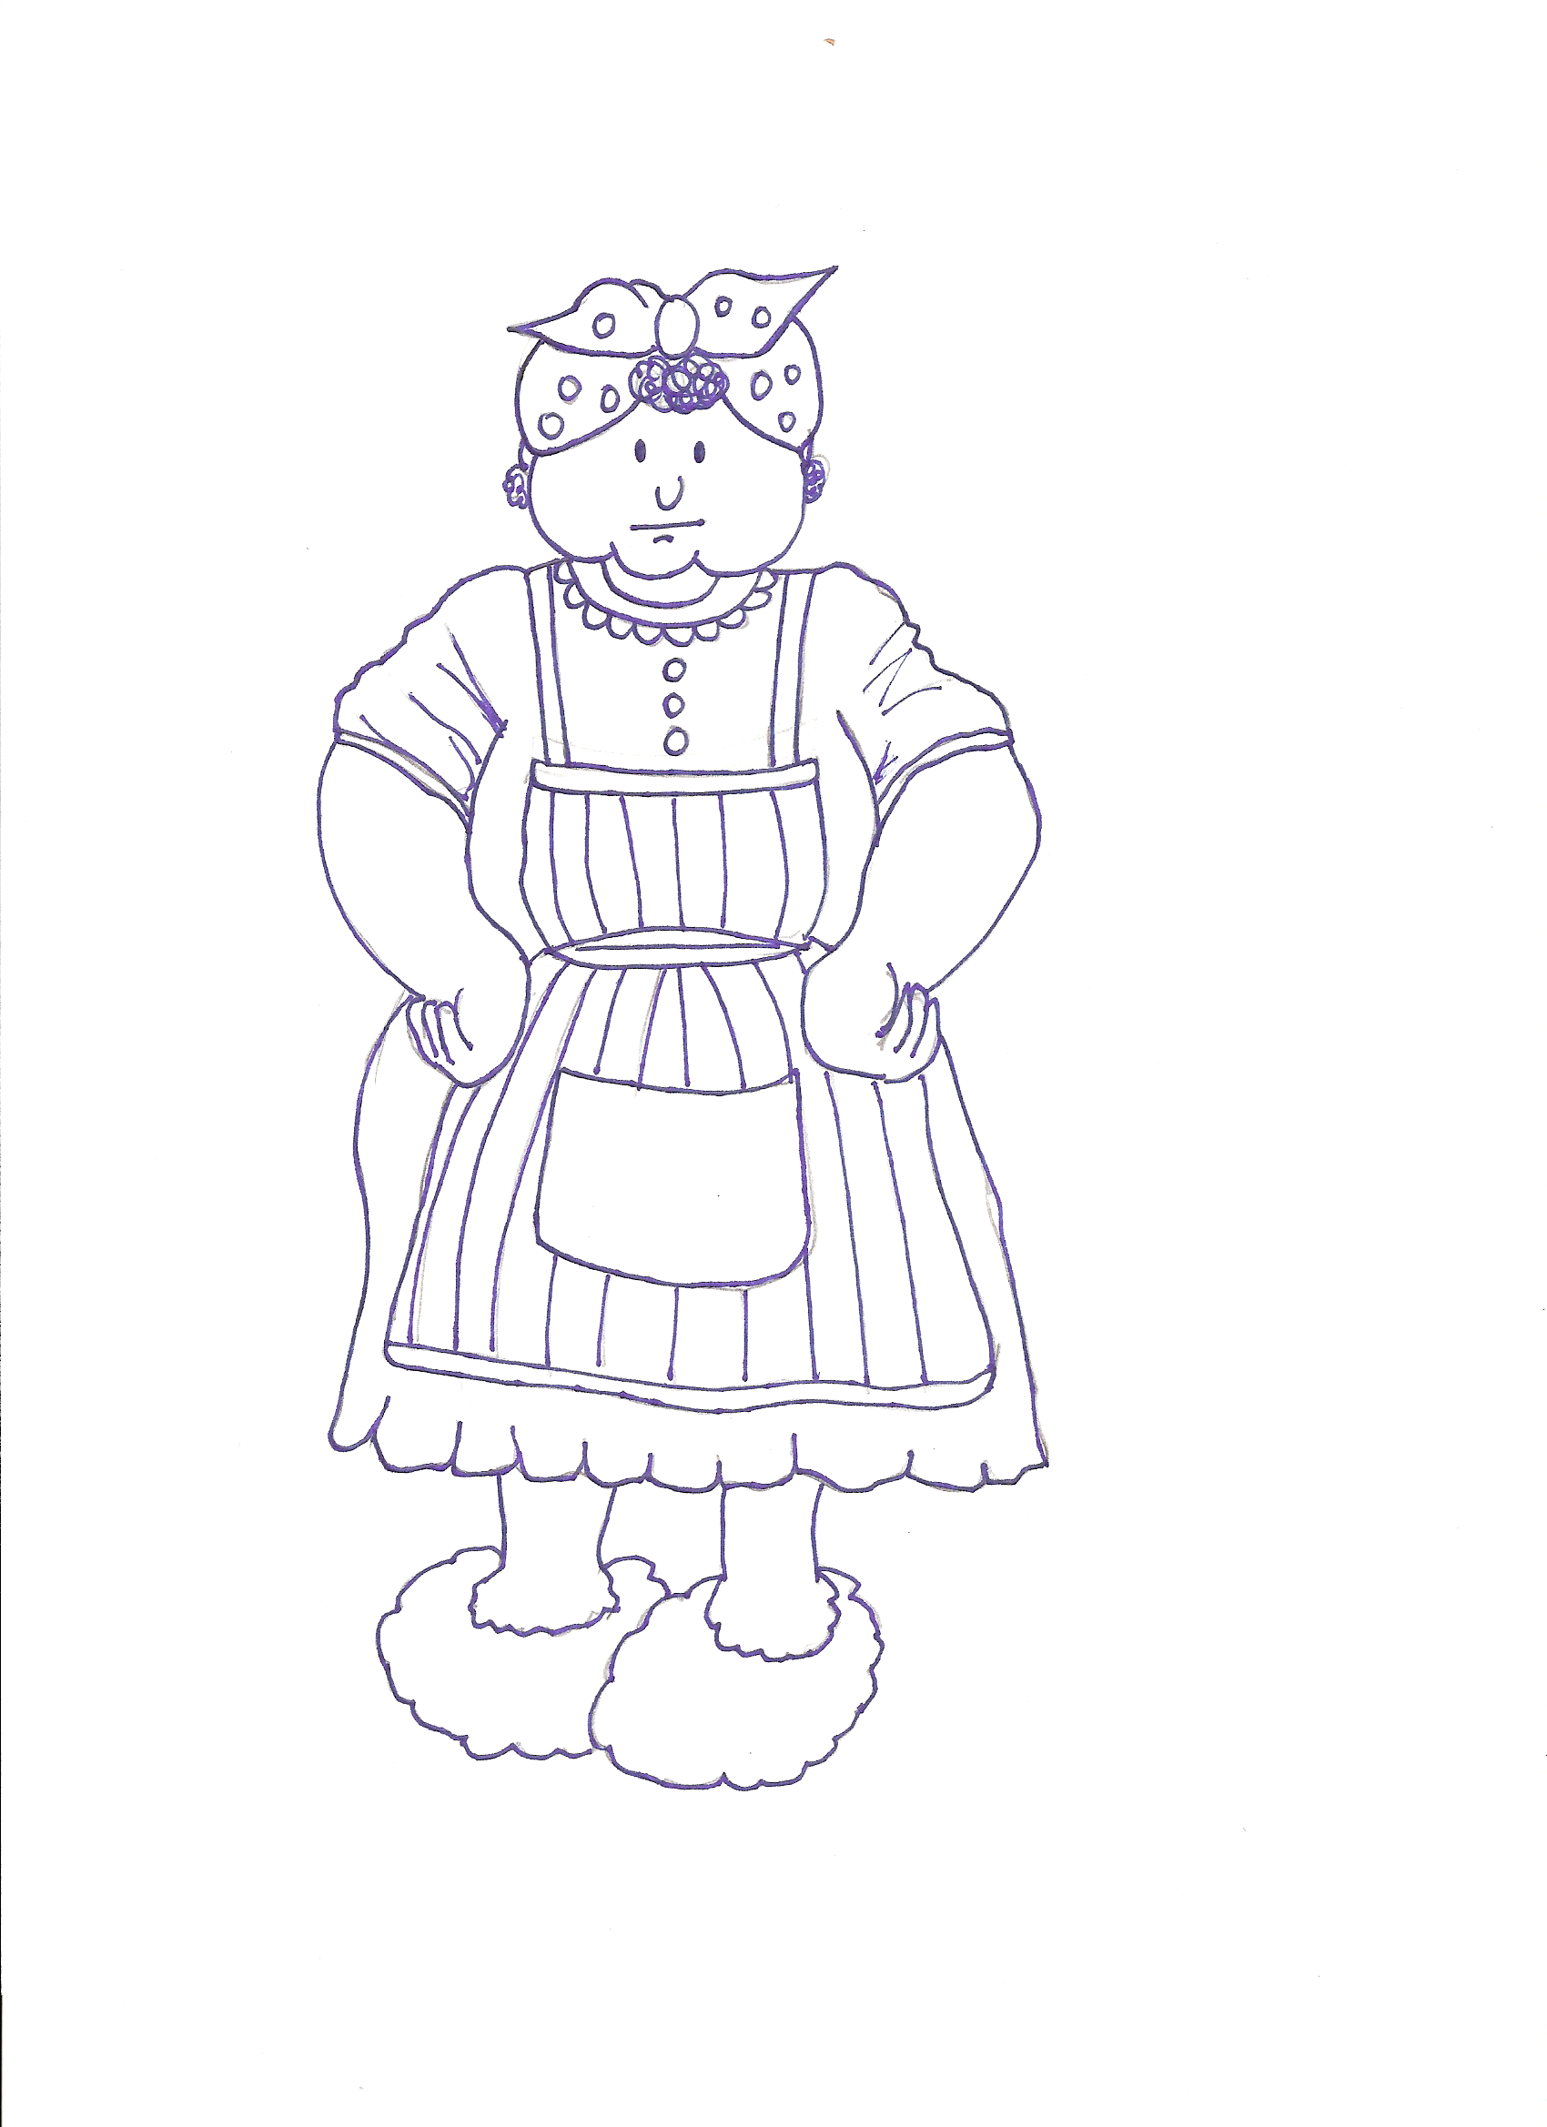

by: ______
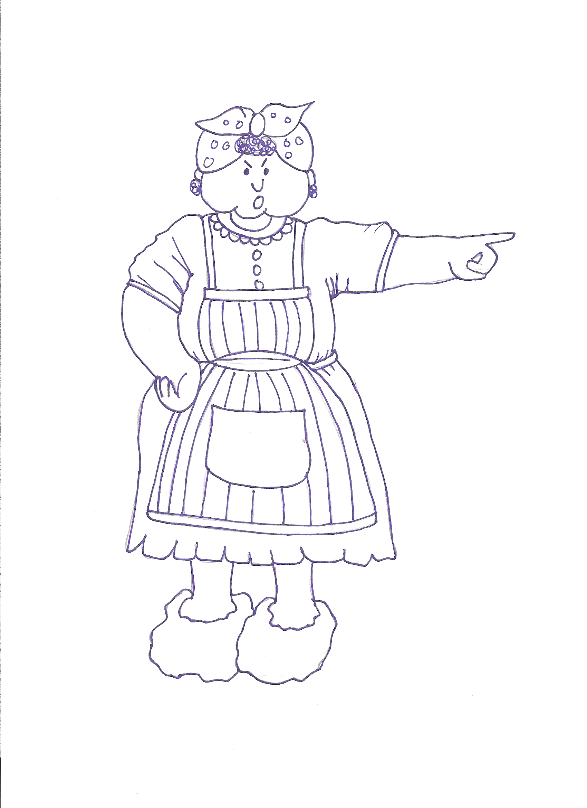
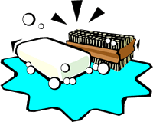

“It’s wishy-washy day. Into __ tub you go.”

___ cow hid in ___ garden.

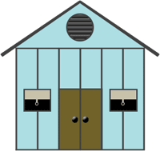

___ dog hid in ___ shed.


___ duck hid in ___ closet.

___ pig hid under ___ bed.

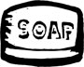

Mrs. Wishy-Washy slipped on ___ soap

and fell in ___ tub instead!

Wishy-washy!
Wishy-washy!

