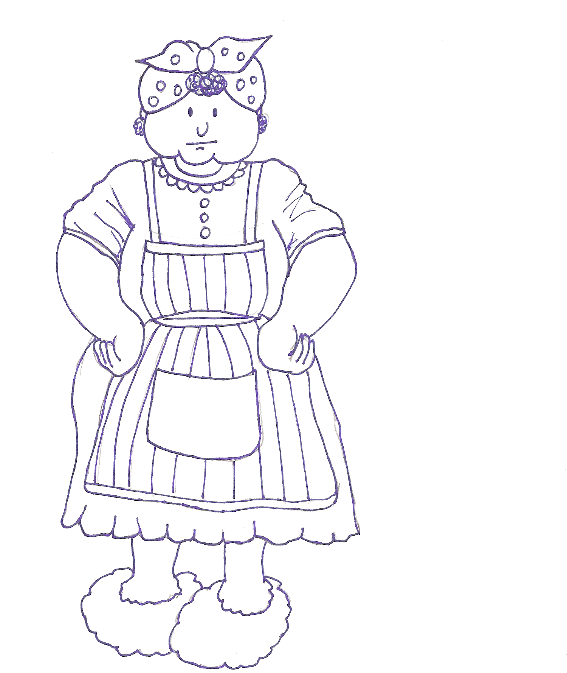

by: ______

The cow is ___ the mud.

The pig is ___ the mud.

The duck is ___ the mud.

Along came Mrs. Wishy-Washy.
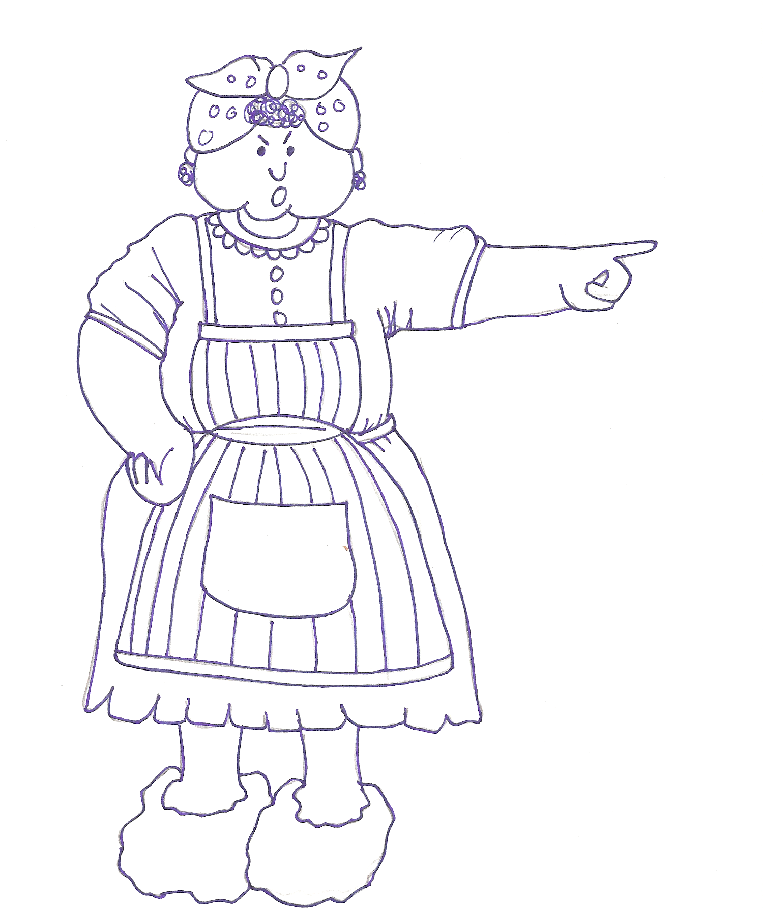

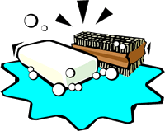

“Into the tub you go!”

__ went the cow,
wishy-washy, wishy-washy.

__ went the pig,
wishy-washy, wishy-washy.

__ went the duck,
wishy-washy, wishy-washy.

Mrs. Wishy-Washy went ___ the house.

___ went the cow!
___ went the pig!
___ went the duck!

