Frog Puppet

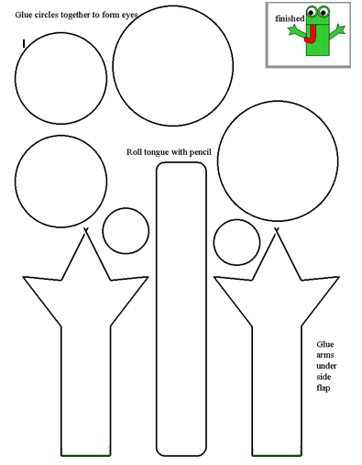
You will need:

Paper Bag
Glue
Crayons
Frog Pieces
Scissors

2.
1.
3.
4.
green

black

red

Color the small circles black. Color the rectangle red.
Cut and glue the pieces to the bag.
Color the large circles and arms green.
Color the bag green.

