Contact Paper Butterfly

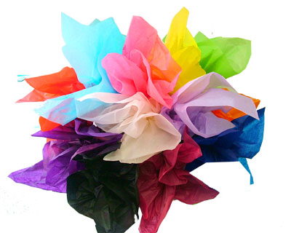
You will need:

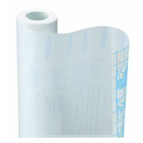

tissue paper
contact paper cut into a butterfly shape

2.
1.
3.
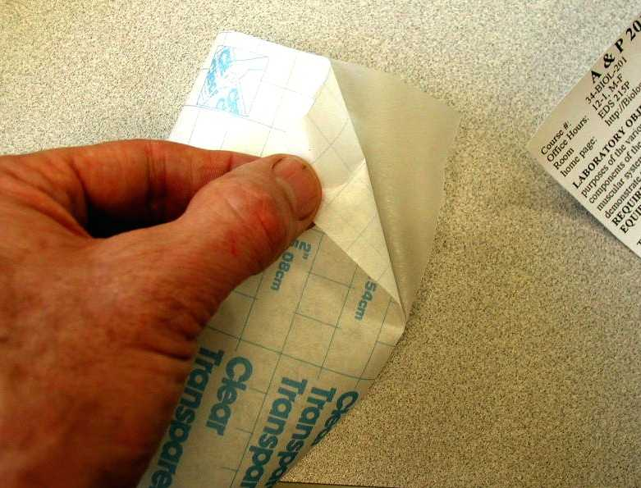

Rip black tissue paper and stick the pieces to the middle of the contact paper to make the body.
Peel the backing from the contact paper.
Rip colored tissue paper and stick the pieces to the contact paper. Remember to make your butterfly symmetrical.

