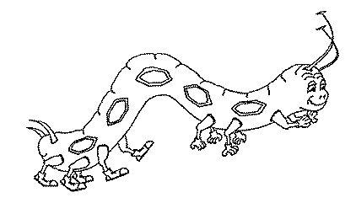
Name:
Name:
On
the
caterpillar started to look for food.
On
the
caterpillar started to look for food.
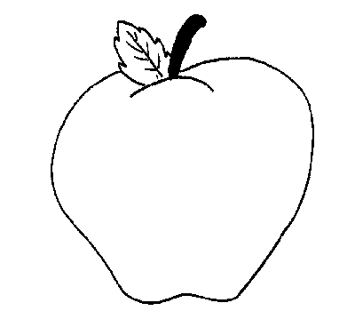
On
he
ate apple.
On
he
ate apple.
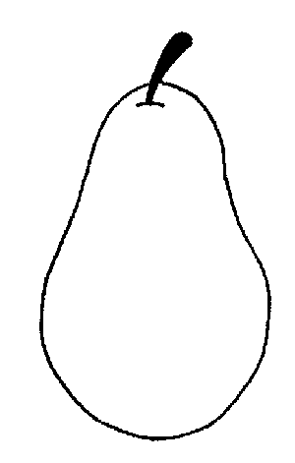
On
he
ate pears.
On
he
ate pears.
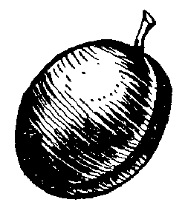
On
he
ate plums.
On
he
ate plums.
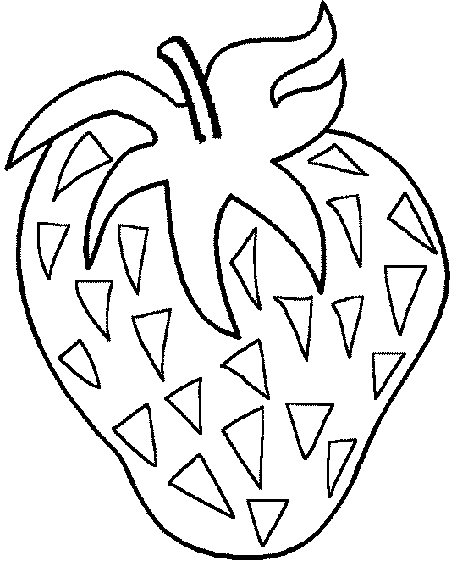
On
he
ate
strawberries.
On
he
ate
strawberries.
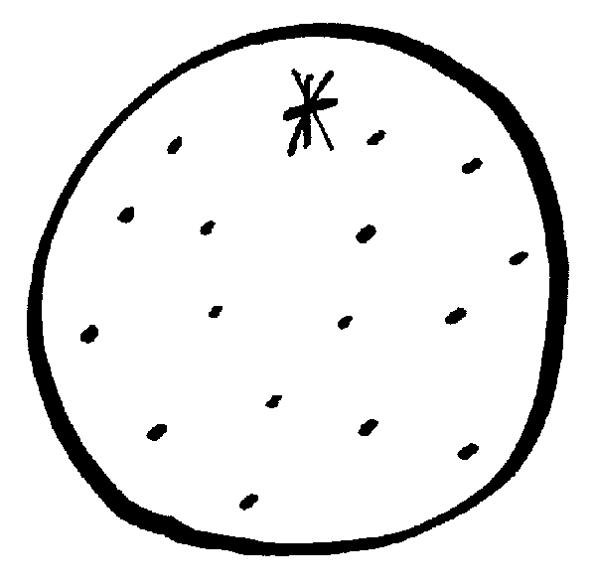
On
he
ate oranges.
On
he
ate oranges.
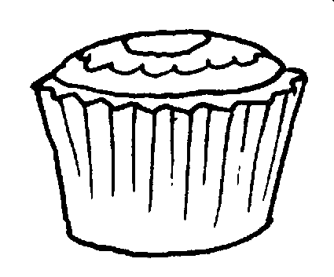
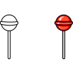
On
he
ate:
On
he
ate:
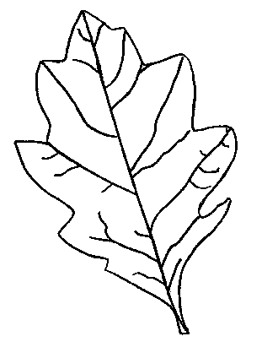
On
he
ate nice green leaf.
On
he
ate nice green leaf.

