Marble Paint Bee


You will need:
black
pipe cleaner
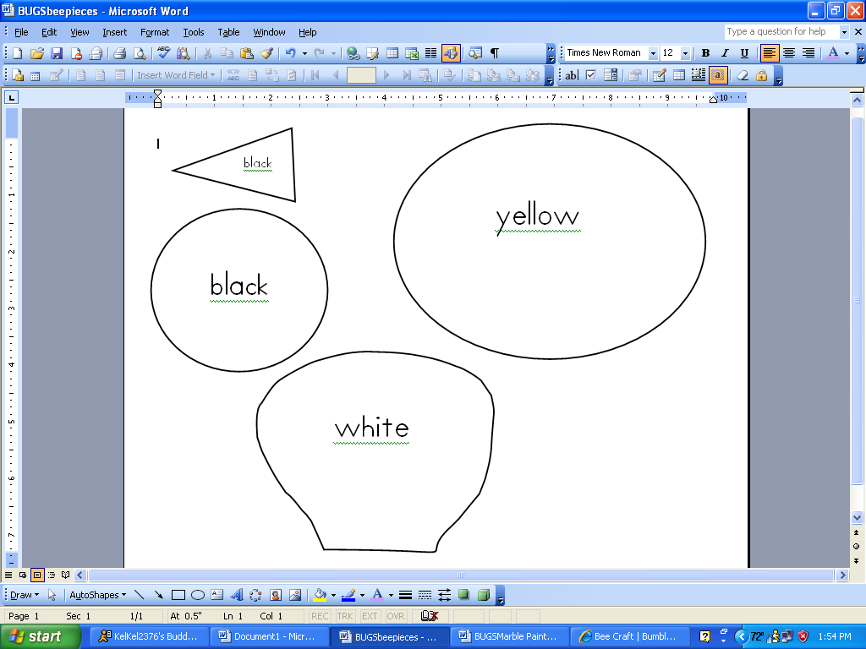
scissors
coffee filter
pencil
yellow

paper
glue
black paint
templates
marble
box

2.
1.
3.
4.

Trace and cut 2 wings out of a coffee filter.
Glue the pieces together. Add eyes and antennae.
Put the body in the box with black paint and a marble. Roll to make stripes.
Trace and cut the head, body, and stinger out of paper.

