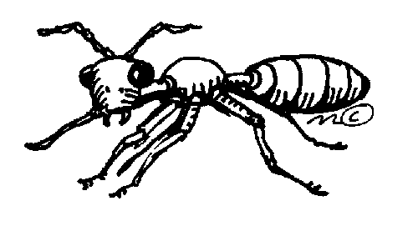
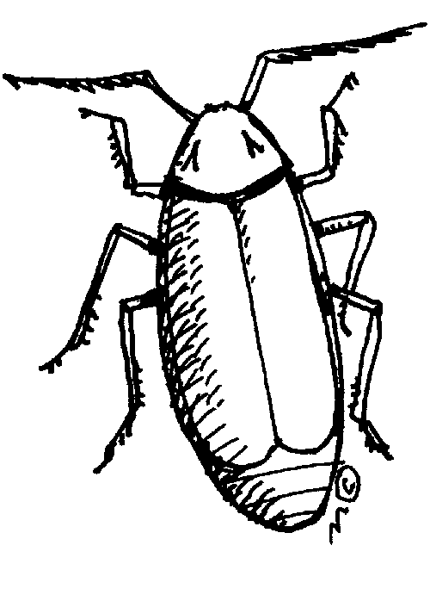

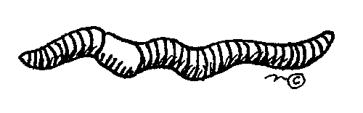

Name:

Name:
2
1
3
Insects have body parts.

Insects have legs.

Insects have antennae.
2
1
3
4
5
6
2
1
2
1
3
2
1
3
4
5
6
2
1
Insects have body parts.

Insects have legs.

Insects have antennae.
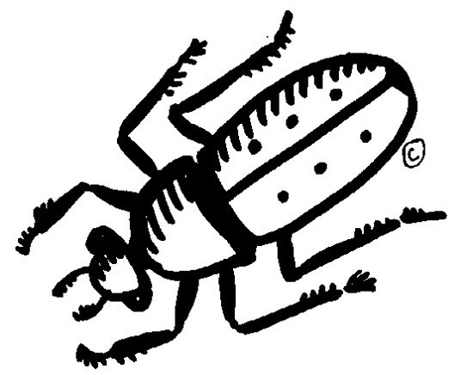
I have 3 body parts? yes no

I have 6 legs? yes no

I have 2 antennae? yes no
I an insect.
beetle

I have 3 body parts? yes no

I have 6 legs? yes no

I have 2 antennae? yes no
I an insect.

I have 3 body parts? yes no

I have 6 legs? yes no

I have 2 antennae? yes no
I an insect.
I have 3 body parts? yes no

I have 6 legs? yes no

I have 2 antennae? yes no
I an insect.

I have 3 body parts? yes no

I have 6 legs? yes no

I have 2 antennae? yes no
I an insect.
I have 3 body parts? yes no

I have 6 legs? yes no

I have 2 antennae? yes no
I an insect.

I have 3 body parts? yes no

I have 6 legs? yes no

I have 2 antennae? yes no
I an insect.
I have 3 body parts? yes no

I have 6 legs? yes no

I have 2 antennae? yes no
I an insect.

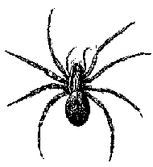

I have 3 body parts? yes no

I have 6 legs? yes no

I have 2 antennae? yes no
I an insect.
I have 3 body parts? yes no

I have 6 legs? yes no

I have 2 antennae? yes no
I an insect.

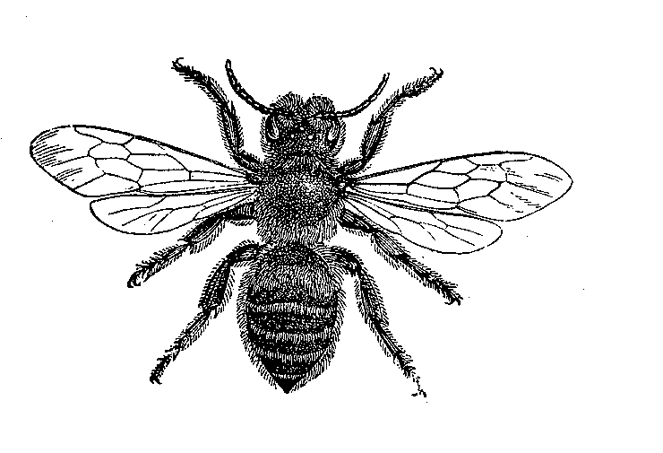
I have 3 body parts? yes no

I have 6 legs? yes no

I have 2 antennae? yes no
I an insect.
I have 3 body parts? yes no

I have 6 legs? yes no

I have 2 antennae? yes no
I an insect.
bee

bee

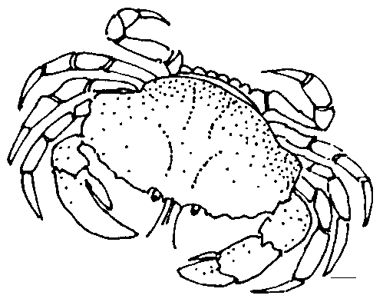
I have 3 body parts? yes no

I have 6 legs? yes no

I have 2 antennae? yes no
I an insect.
I have 3 body parts? yes no

I have 6 legs? yes no

I have 2 antennae? yes no
I an insect.
crab

crab

