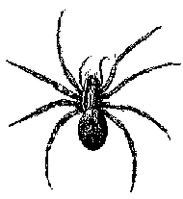

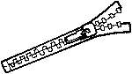
g
s
h
p
j
n
b
z

