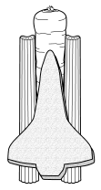
Space Shuttle Snack

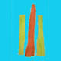  Put a little peanut butter on the sides of the carrot. Then, stick the celery onto the carrot. | 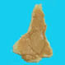  Spread peanut butter on the Orbiter bread. | 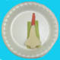  Put the bread onto the carrot and celery.
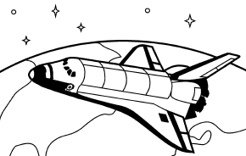
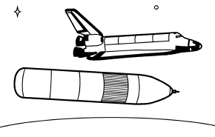
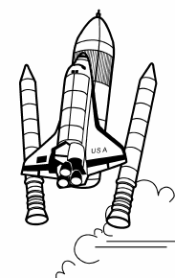
You can eat your space shuttle in the order that it launches:
The rocket boosters fall off.
The external fuel tank falls off.
The orbiter continues into space.

