The | I | and | with
see | is | like | to
run | play | can | cat
dog | bug | a | the
big | little | funny | .

The | I | a | the
see | is | like | my
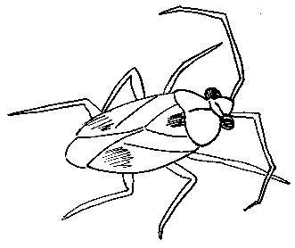  bug | 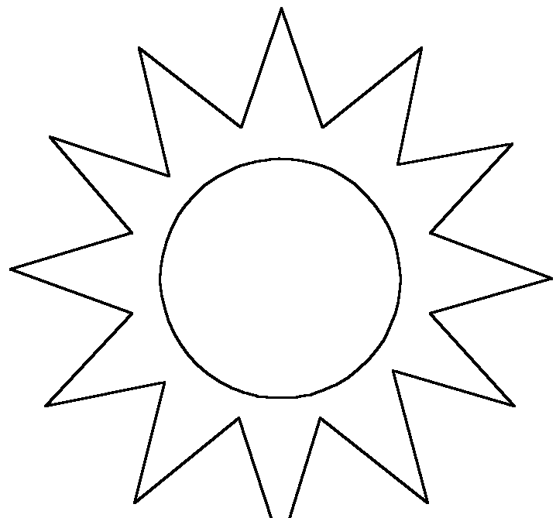  sun | 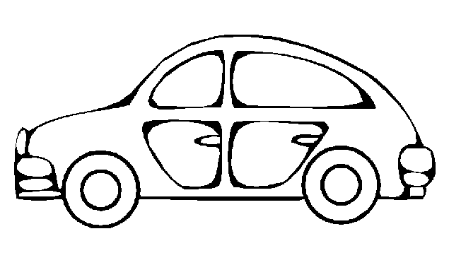  car | 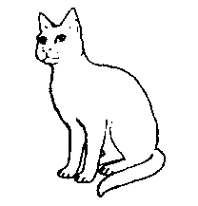  cat
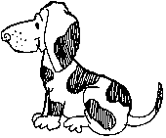  dog | 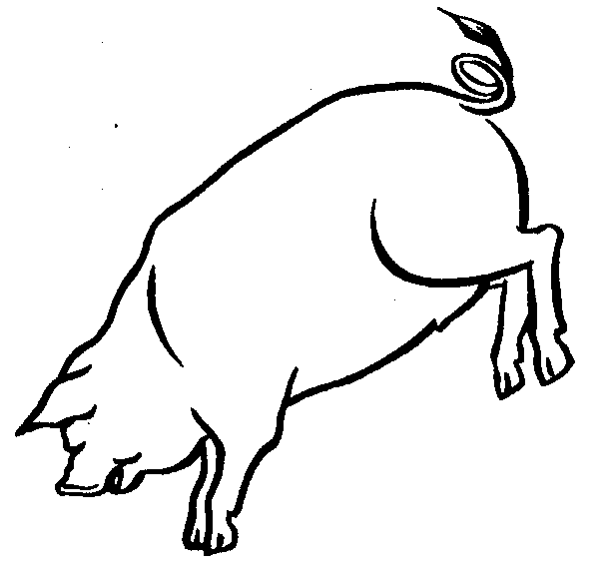  pig | red | green
big | yellow | brown | .

.

