Rainbow Magnets
Write your name on the back of the circle. | 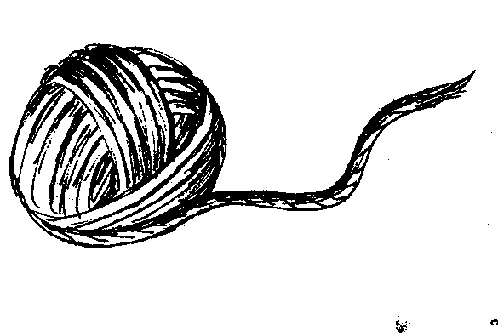  Glue the yarn on the black circle.
Glue the cotton ball to make a cloud. | Let your rainbow dry.
Rainbow Colors

red
orange
yellow
green
blue
purple

