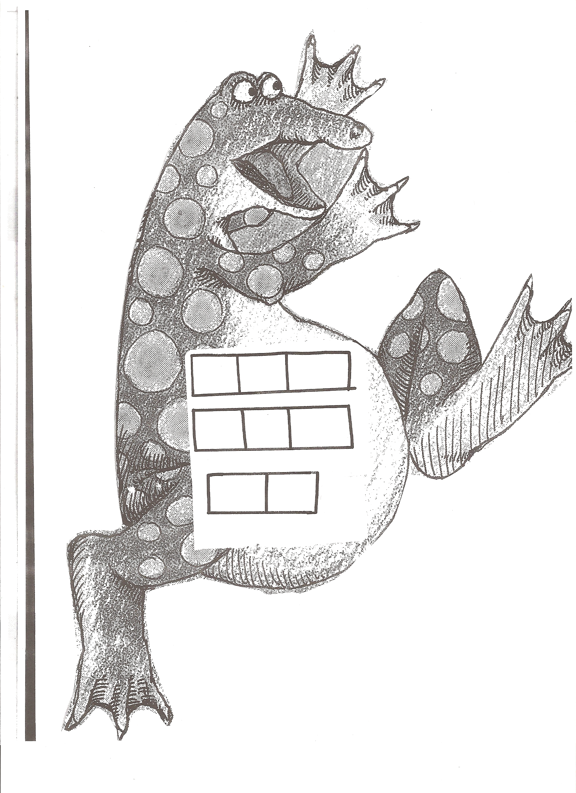
Cut out the letters to make the words. Glue the words to your Jigaree.

a
e
e
e
e
e
f
here
there
after
h
h
r
r
r
t
t

Cut out the letters to make the words. Glue the words to your Jigaree.

a
e
e
e
e
e
f
here
there
after
h
h
r
r
r
t
t

