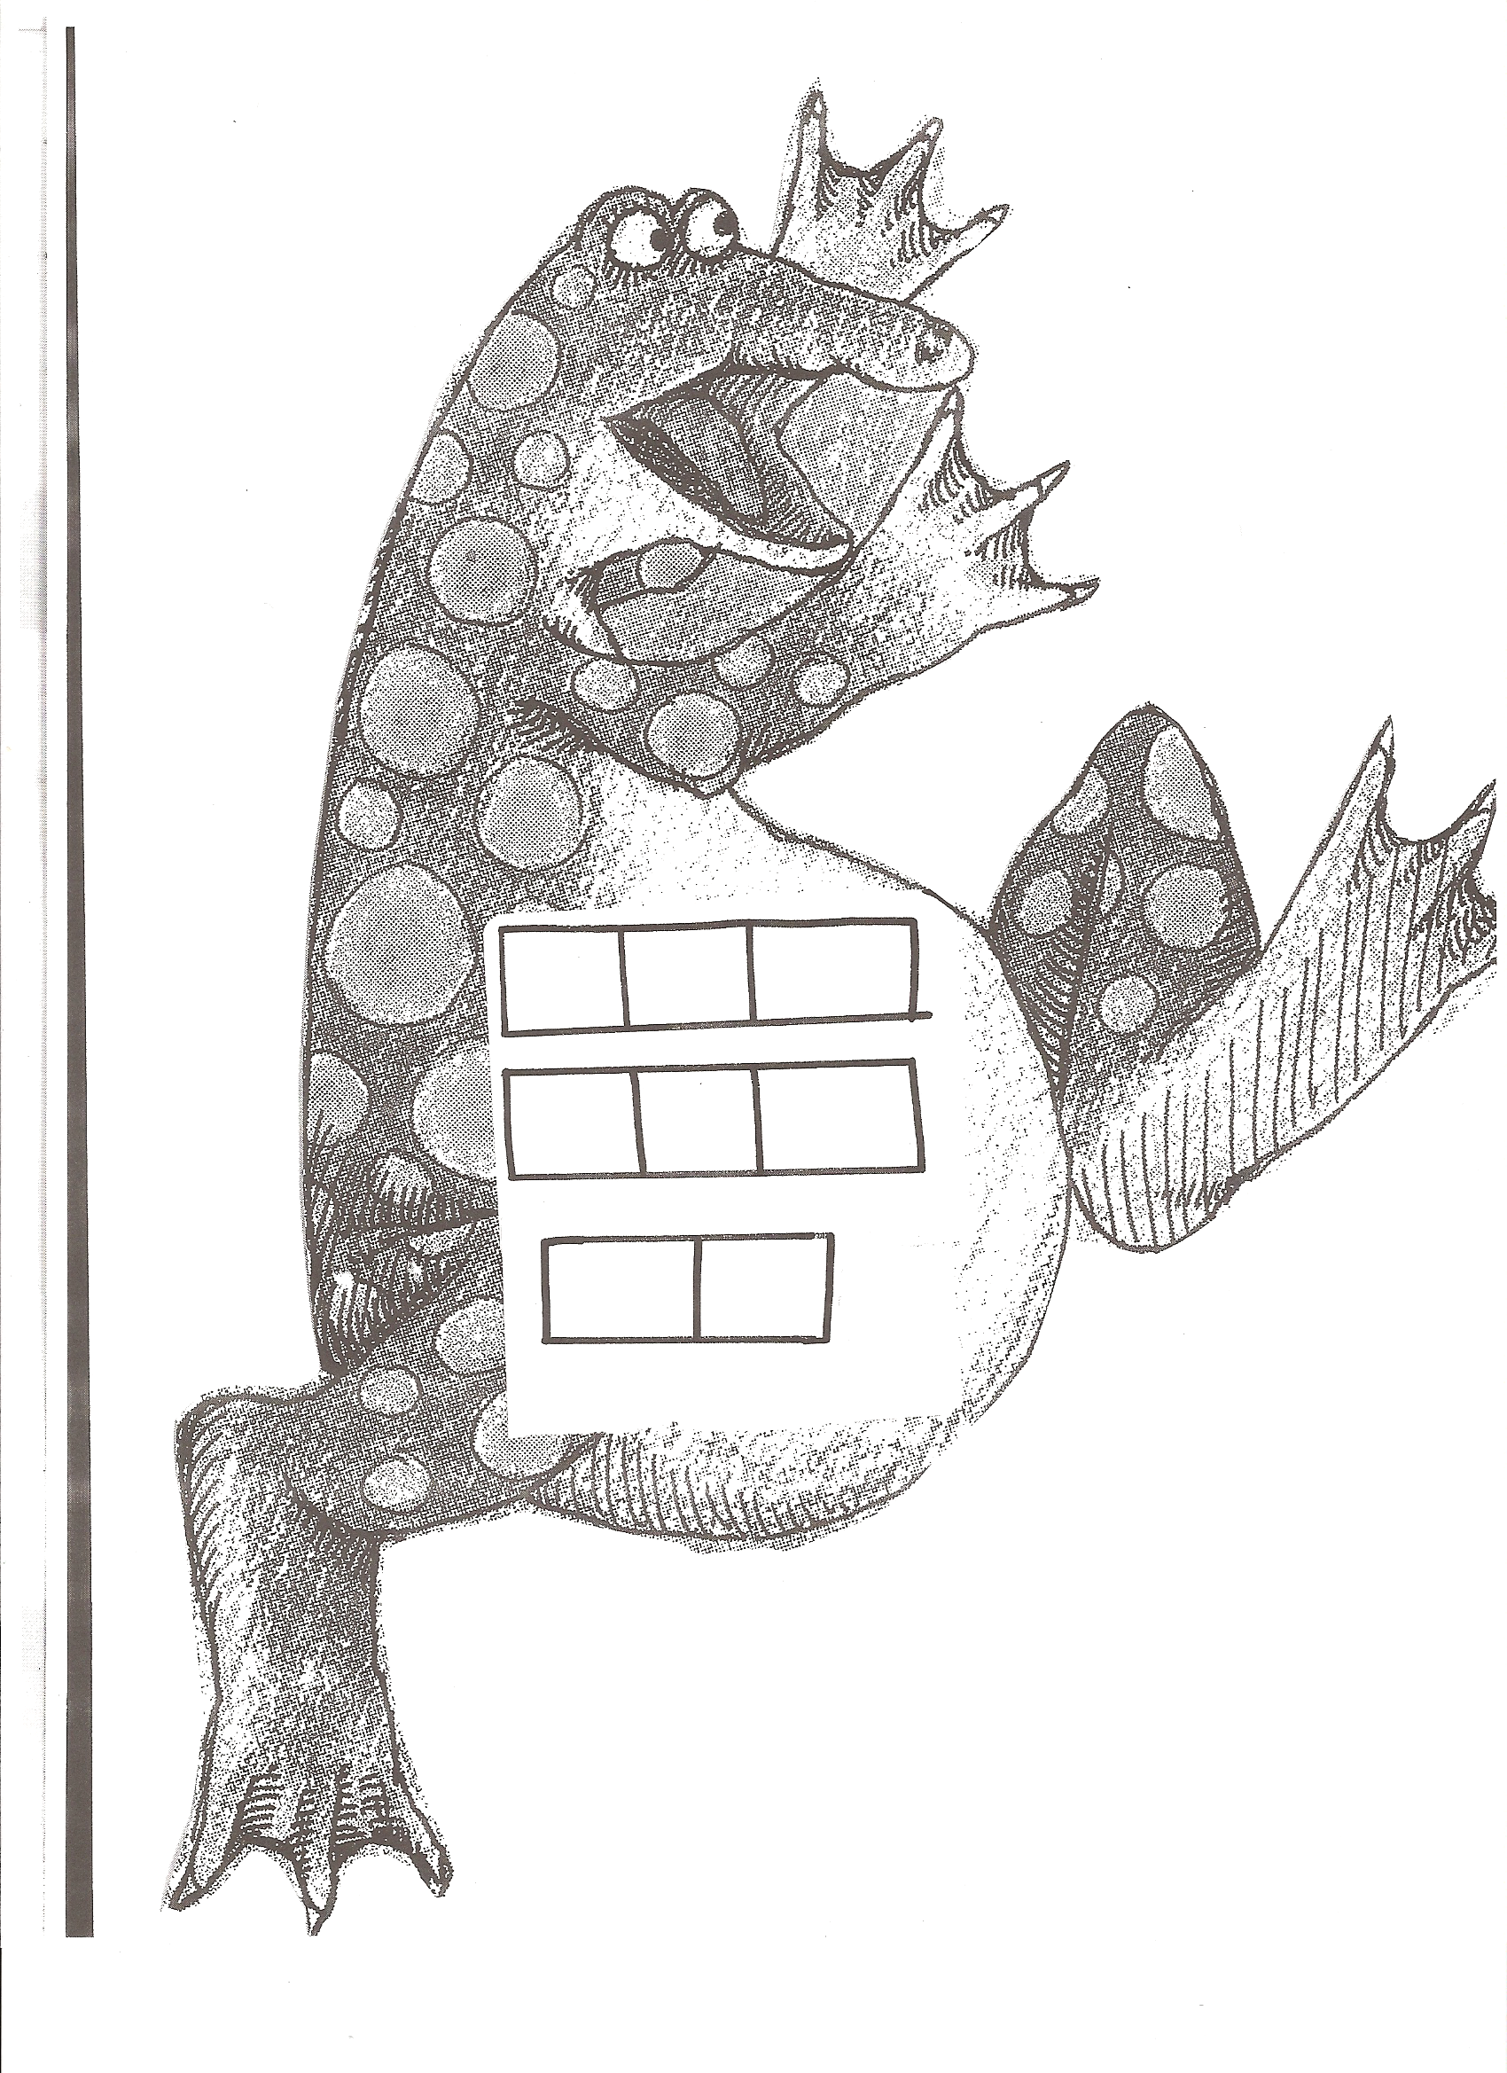
Cut out the letters to make the words. Glue the words to your Jigaree.

a
c
e
e
e
m
n
s
can
me
see

Cut out the letters to make the words. Glue the words to your Jigaree.
a
c
e
e
e
m
n
s
can
me
see

