Prediction |  | Actual  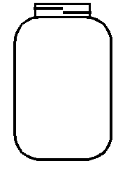
wooden stick | paper clip |  | 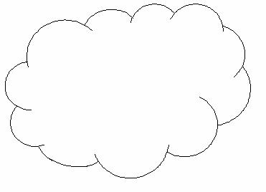  co tton ball
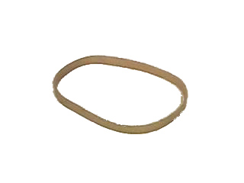  rubber band | crayon |  | 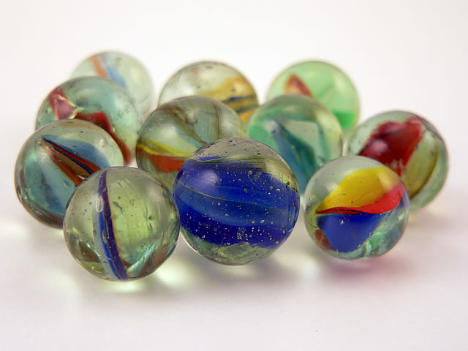  marble
pencil | key |  | 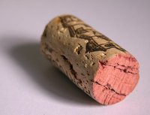  cork
paper | scissors |  | tack
sink | sink |  | sink
float | float |  | float
sink | sink |  | sink
float | float |  | float
sink | sink |  | sink
float | float |  | float
sink | sink |  | sink
float | float |  | float
sink | sink |  | sink
float | float |  | float
sink | sink |  | sink
float | float |  | float
sink | sink |  | sink
float | float |  | float
sink | sink |  | sink
float | float |  | float

