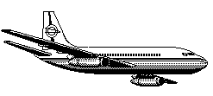
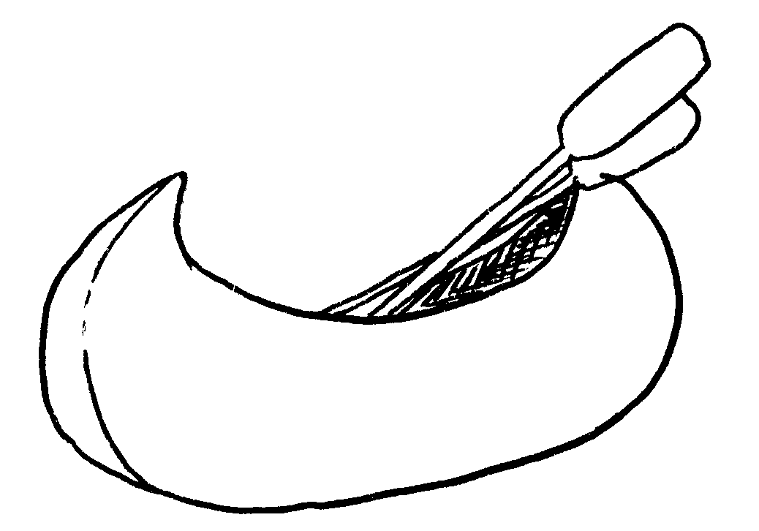
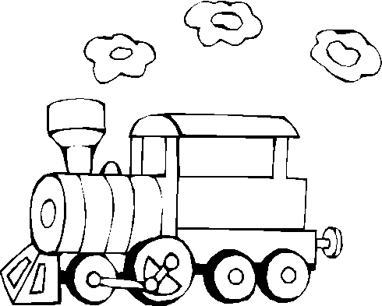
by
go
he
Will
?
by
go
he
Will
?
by
go
he
Will
?
by
go
he
Will
?
by
go
he
Will
?
by
go
he
Will
?

