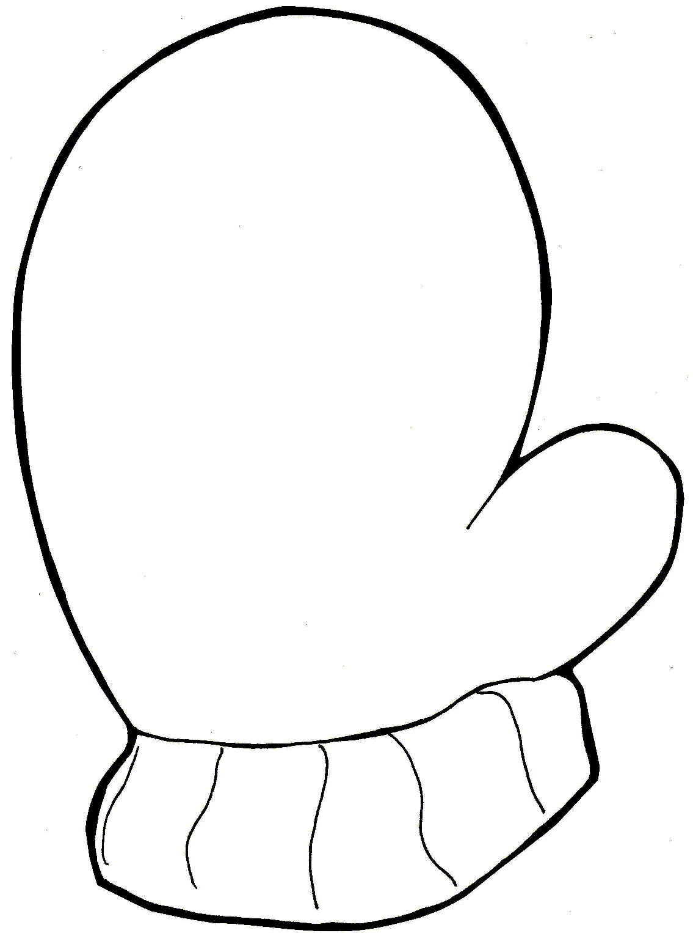
Name:

Name:

AB Pattern

My pattern is

AB Pattern

My pattern is

AAB Pattern

My pattern is

AAB Pattern

My pattern is

ABC Pattern

My pattern is

ABC Pattern

My pattern is

