hammer | pliers | saw
level | tape measure | wrench
screwdriver

hammer | pliers | 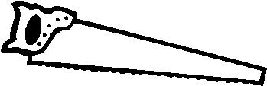  saw
level | tape measure | wrench
screwdriver

