green | for | down
big | my | and
you | are | me
the | be | yes
like | up | can
two | see | we
do | no | will
six | it | in
you | in | green
are | for | it
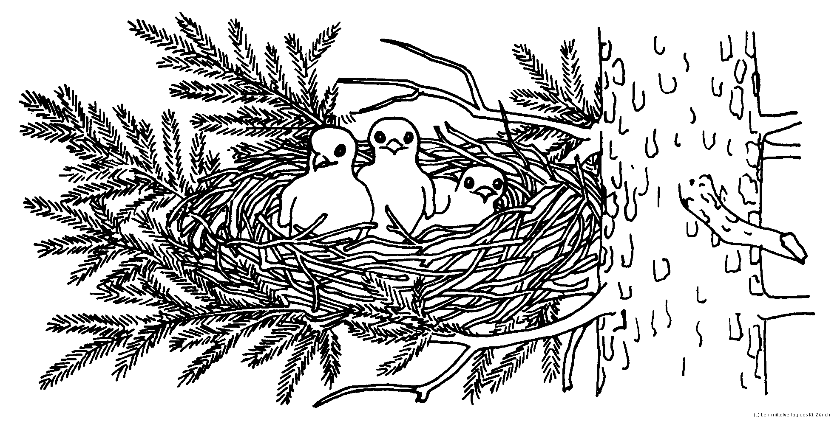
me | the | like
will | down | do
you | in | green | are | for | it
me | the | like | will | down | do
green | for | down | big | my | and
you | are | me | the | be | yes
like | up | can | two | see | we
do | no | will | six | it | in

