pretty | over | said
where | help | find
went | funny | out
under | come | this
want | not | from
make | of | some
was | what | little
away | who | come
funny | said | where
pretty | under | want
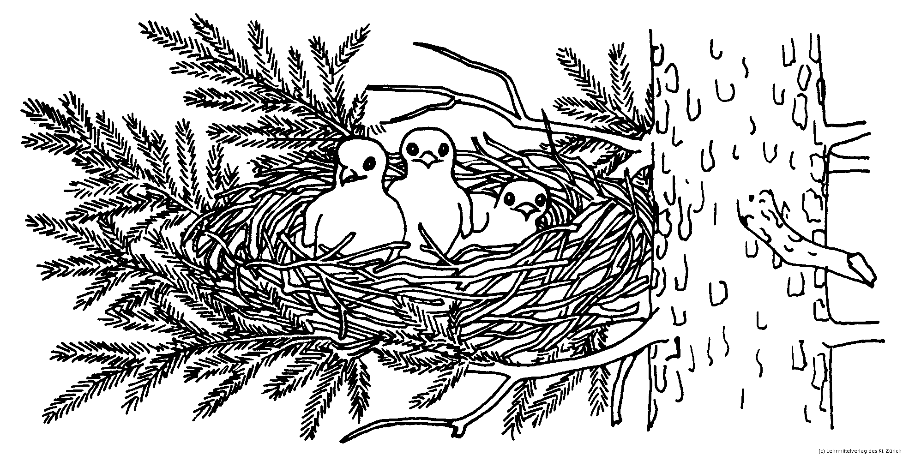
went | little | was
what | from | make
pretty | said | where | went | want | under
come | this | from | make | of | some
was | what | little | away | who | over
help | find | funny | out | not | make
from | what | was | little | went | want
under | pretty | where | said | funny | come

