Name:


Glue the letters to spell the words.
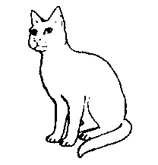
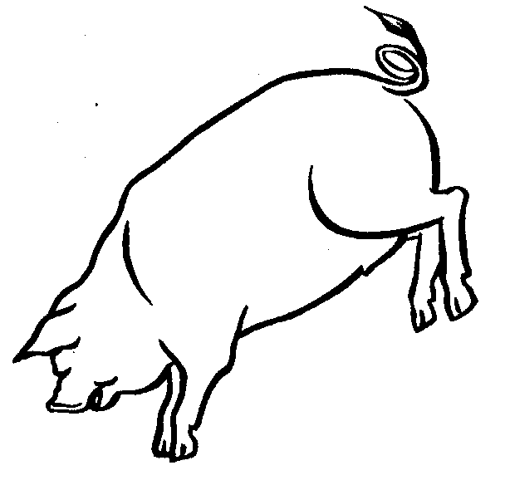
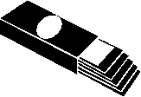
a
t
m
g
x
c
b
o
p
i
g
u
a
t
m
g
x
c
b
o
p
i
g
u

