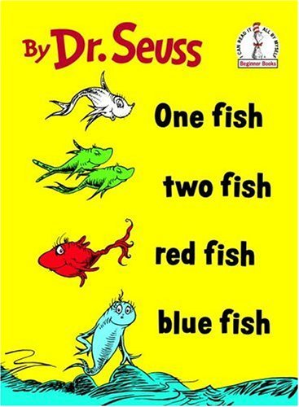
_________________________________________

_ _ _ _ _ _ _ _ _ _ _ _ _ _ _ _ _ _ _ _ _ _ _ _ _ _ _ _ _ _ _ _

_________________________________________
My Creature’s Name

What does your creature eat?

_ _ _ _ _ _ _ _ _ _ _ _ _ _ _ _ _ _ _ _ _ _ _ _ _ _ _ _ _ _ _ _ _ _ _ _
_______________________________________________________

_ _ _ _ _ _ _ _ _ _ _ _ _ _ _ _ _ _ _ _ _ _ _ _ _ _ _ _ _ _ _ _ _ _ _ _
_______________________________________________________

Where does your creature live?

_ _ _ _ _ _ _ _ _ _ _ _ _ _ _ _ _ _ _ _ _ _ _ _ _ _ _ _ _ _ _ _ _ _ _ _
_______________________________________________________

_ _ _ _ _ _ _ _ _ _ _ _ _ _ _ _ _ _ _ _ _ _ _ _ _ _ _ _ _ _ _ _ _ _ _ _
_______________________________________________________

What does your creature like to do?

_ _ _ _ _ _ _ _ _ _ _ _ _ _ _ _ _ _ _ _ _ _ _ _ _ _ _ _ _ _ _ _ _ _ _ _
_______________________________________________________

_ _ _ _ _ _ _ _ _ _ _ _ _ _ _ _ _ _ _ _ _ _ _ _ _ _ _ _ _ _ _ _ _ _ _ _
_______________________________________________________

_______________________________________________
_ _ _ _ _ _ _ _ _ _ _ _ _ _ _ _ _ _ _ _ _ _ _ _ _ _ _ _ _ _ _
Name:
_______________________________________________

