Name:

Glue the rhyming words.
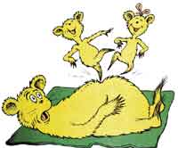
mop
cat
sun
bag

