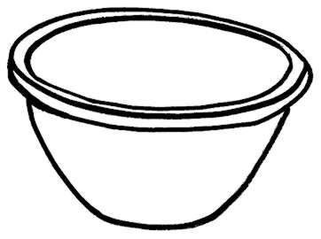
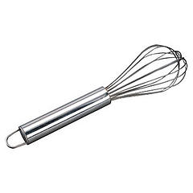
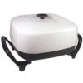
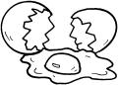
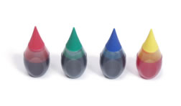
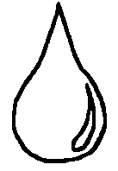
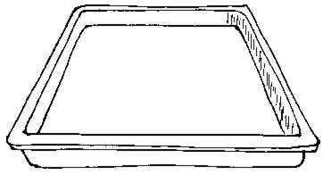
Cut out the pictures. Put in order to show how to make green eggs and ham.
Beat the eggs.
Tear up the ham. Add it to the bowl.
Turn on the frying pan.
Crack the eggs into the bowl.
Add green food coloring.
Pour into the frying pan. Cook.

