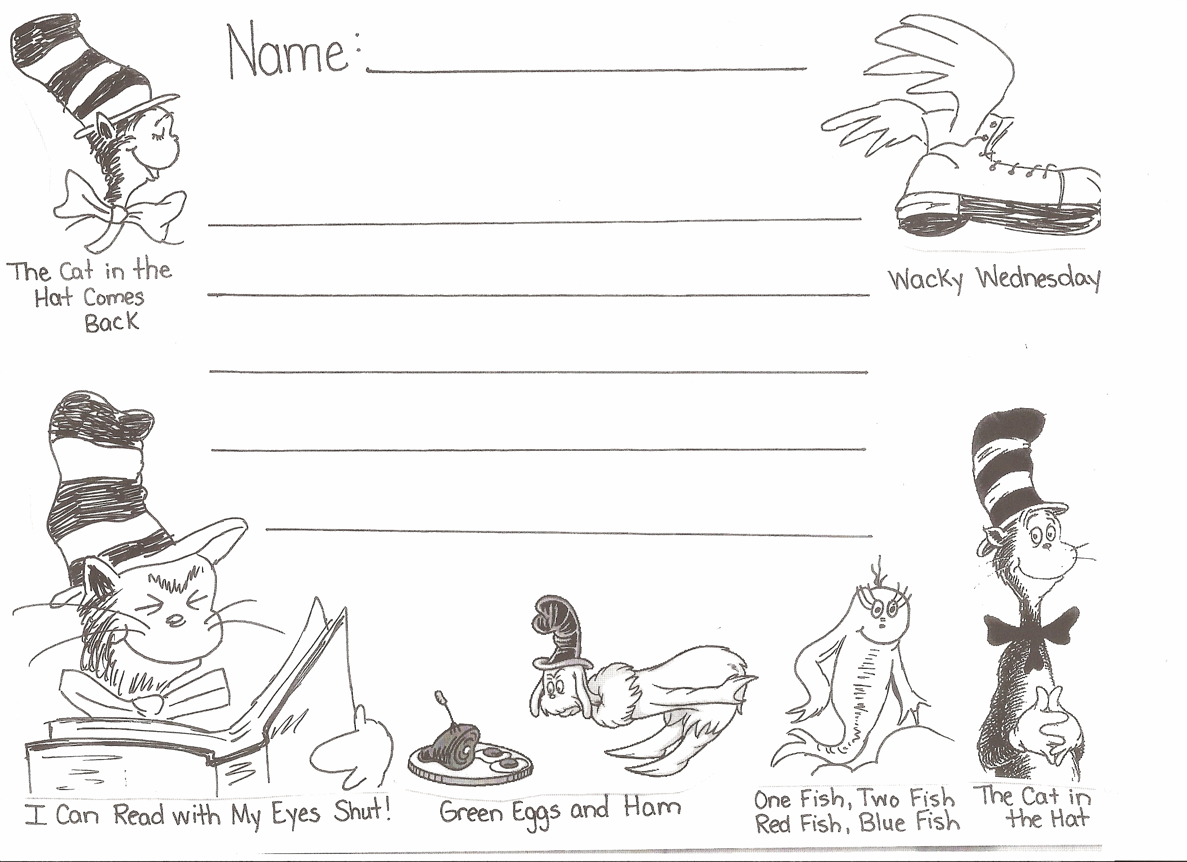
Name:
Which Dr. Seuss book is your favorite?

