Name:

Name:

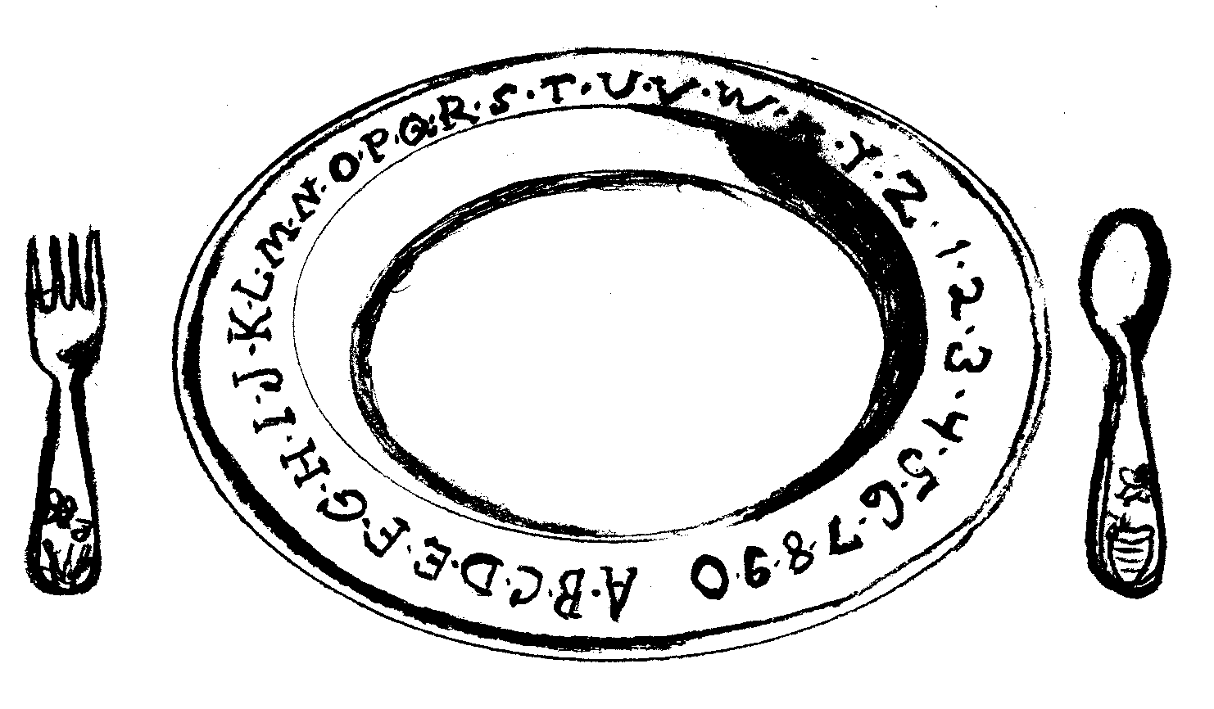
I can eat 100

I can eat 100



I can wear 100

I can wear 100
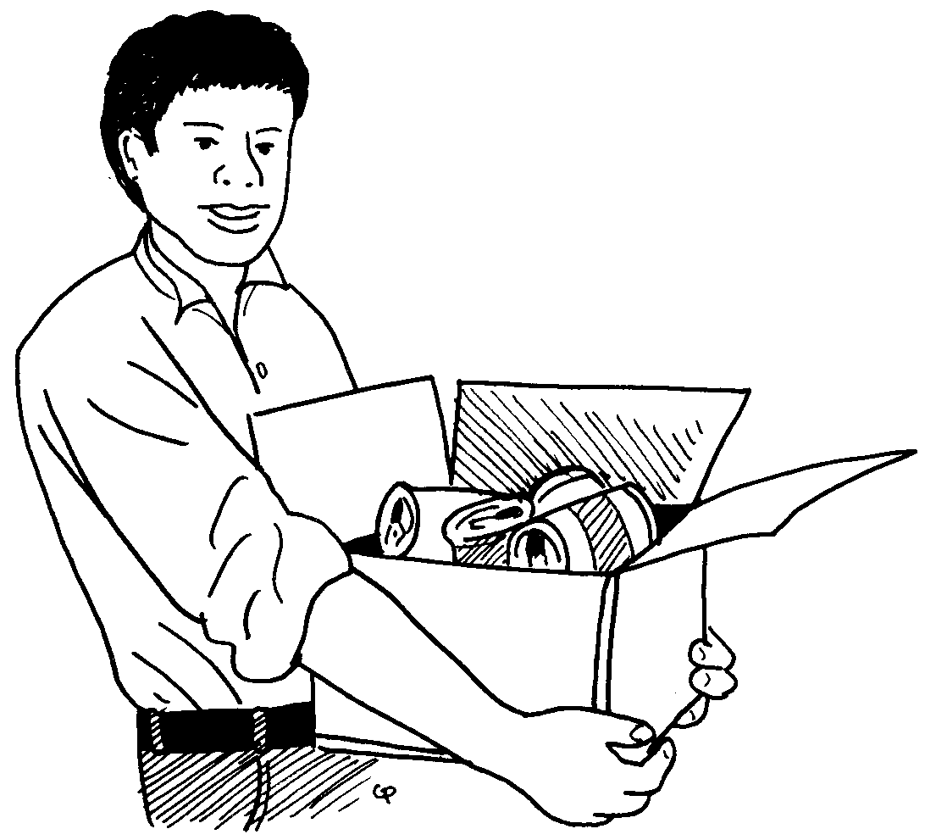
I can carry 100
I can carry 100
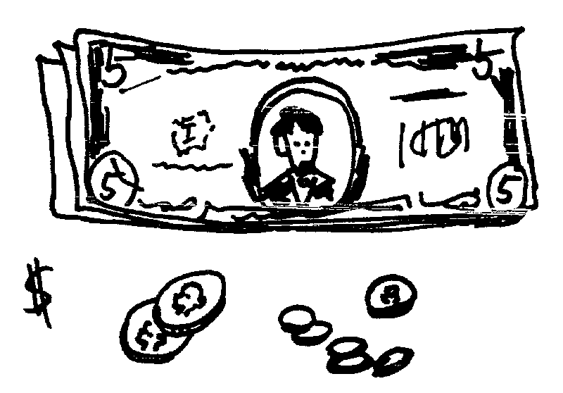
I can buy 100
I can buy 100

