a horse.
In a corner of a library, a story was just beginning.

a rabbit.

a frog.
a kangaroo.
a jellyfish.
a seal.
a goat.

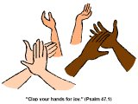
At the end of the story, the children clapped and cheered.
“Sssh!” said the animals.
“Quiet in the library!”
The End!
by:

