Name:

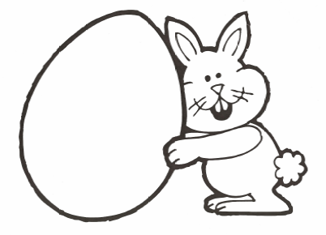
looking
at
me
see
what
you
do

Write the word.

